How Grant Accounting is Setup Under Chart V
1) Award received and ready for set up - OSP sets up a Grant Code which captures the details of the entire award, such as start and end dates, authorized amount, cost share obligation (if any), personnel, and billing and reporting. This code is set up using a letter code for the college and the department, and the last four digits of the fund code. Example:
S (Science) C (Chemistry) 2225
The relevant screens that use the Grant Code are FRAGRNT, FRIGRNT, FRAPROP, FRIGITD, and FTMFUND. This code is NOT part of the FOAPAL table.
If you have a 'Companion' account for cost share or program income that Grant Code will be the same as the award Grant Code, but with a 'C' added to the end, e.g. SC2225C.
2) The award is put into one or more Fund Codes at the request of the associated department(s). Any extra funds are usually requested when the proposal is submitted, but may also be set up later to separate things such as subawards from the main fund. The fund codes for sponsored projects will always start with '22.' If there is more than one associated fund then the 'main' fund will be the one matching the grant code. Example:
Above Grant Code would have an associated Fund Code of 222225.
The relevant screens that use the Fund Code are FTMFUND, FRIGITD, and FTMACCI.
3) When the fund codes are set up OSP will also set up an associated Index for each fund. The first three digits of the index will be the Organization Code and the last three will be set up one down from the last index used for that Org.
The relevant screens that use the Index are FRIGITD, FTMACCI and any data entry screens that allow use of the the index as a shortcut for the FOAPAL (e.g. FGAJVCD).
Q: I only know my Index, so how do I know what my Fund Code and Grant Code are?
A: If you go to FRIGITD and enter your Index and tab over it will flood in both the Fund and the Grant Code.
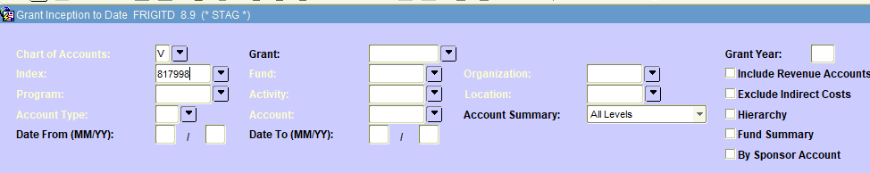
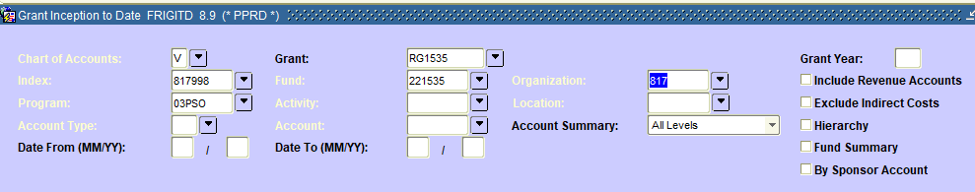
A: If you go to FTMACCI and query on your Index it will show you the Fund Code. Generally you can then get to your Grant Code by associating your college and department code with the last four of the Fund.
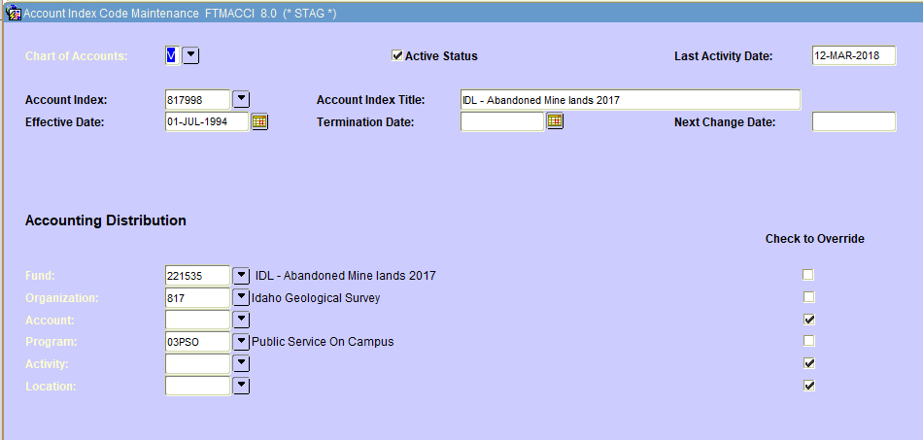
A: If your Fund is not the main fund you can query in FTMFUND and that will display the Grant Code.
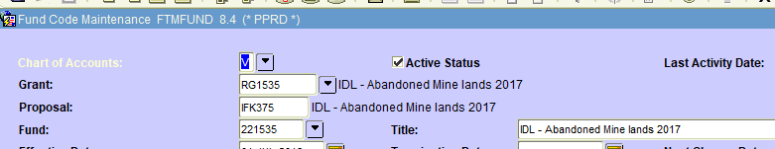
Q: Is there a way to find my new Grant Code using my old Grant Code or vice versa, other than the crosswalks provided in Argos?
A: To find your new Grant Code if you know your old Grant Code go to FRAPROP and enter your old Grant Code and page down. Your new Grant Code will be in a field towards the lower right corner.
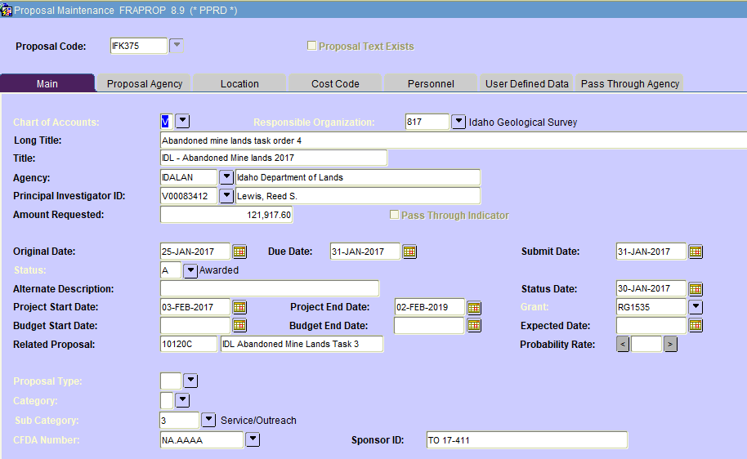
A: To find your old Grant Code if you know your new Grant Code go to FRAGRNT and enter your new Grant Code and page down. Your old Grant Code will be in a field in the upper right.
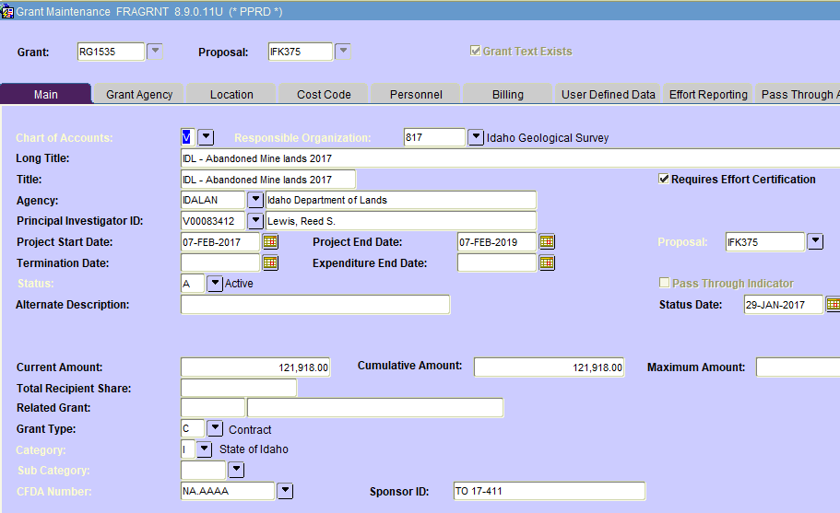

Or, you can also see your old Grant Code by looking at the new Proposal Code in FTMFUND.

