DGA Roundtable Minutes: 08/17/2023 1:30 pm pacific on zoom
- Website updates –
  - Institutional base salary - Personnel Expenses (salaries and fringe benefits) (uidaho.edu) (an update to APM 45.09 is in process to clarify IBS definition)
  - Escalations - https://www.uidaho.edu/research/faculty/submit-proposal/proposal-faqs#accordion-row-a6924d7a-68b0-4d53-b57e-b3a21002974b- and budget template update Proposal and Award Forms (uidaho.edu)
  - EO14026 - https://www.uidaho.edu/research/faculty/dga#accordion-row-875a15bc-f84d-4ebd-b3e3-7905f61998d0-
    - USDA ARS RSA has been sent out if it applies
  - From ORA – FCOI (now RCOI) website changes: Research Conflicts of Interest (uidaho.edu)
    - Kay Dee Holmes has sent out a fact sheet for this, important for DGAs, now uploaded to website

- Coming soon – Build America, Buy America fact sheet
  - If there are specific questions about this, please let Sarah know so she can add those questions and answers to the fact sheet
  - This will be a living document in sharepoint, intention is to have the ability for comments added but OSP team will see if some limitations can be added to the edit function so comments can be added but no full edits or changes will be made.
    - Blair/Chelsea exploring “require content approval” in sharepoint as well as other possible options. Require content approval would send a notification to a specific recipient to approve; this could help track questions and respond quicker as well.

- Industry sponsors and setup processes
  - Setup will not occur until 1st payment is received with rare exceptions – this is part of the AAN information;
  - Early setups will not be allowed (w/ rare exceptions)
  - OSP evaluates the financial stability, payment history and organizational longevity of entities when we determine how to structure agreement terms and payment requirements
  - Work should not begin until payment is received and accounting setup is released.
    - We are evaluating changing our industry contract terms to make the start date the date of receipt of payment.
    - If payment schedule is not followed or payment is delinquent, a stop-work order may be needed and PI should refrain from delivery of results or reports until payment is received.
  - LRs should not be submitted for costs incurred before payment was received – work is not supposed to be occurring prior to payment receipt.

- Recently the Idaho State Legislature passed a new law regarding public entities entering into contracts. Under I.C. § 67-2359, (Idaho) public entities are not allowed to enter into contracts with companies that are owned or operated by the government of China (see Section 67-2359 – Idaho State Legislature) and all contracts must carry a certification to that end. As a PI, Co-PI, or departmental staff or proposal/project support member, it is important to note that use of sponsored funding to procure goods or services from a company that is owned or operated by the government of China is prohibited and you need to be aware of this as part of your financial oversight responsibilities.

  - You will soon see language similar to the below in some incoming and out-going sponsored funding agreements and subawards:
    - Sponsor/subrecipient/entity certifies, warrants, and represents that it is not currently owned or operated by the government of China and will not for the duration of this agreement/subaward be owned or operated by the government of China per Idaho Code §67-2359.

- Protocol process (why setups are held for compliance items)
  - Working with animal subjects, human subjects, a number of other reasons
  - Most of the time you do not need an active approved protocol to submit a proposal
  - Post award must ensure that your protocol and scope of work match so they must wait for iacuc or irb to assure that the scope and protocol match, if it does not then they will issue an amendment.
  - Main takeaway: OSP cannot process early setup without a protocol in place.
  - Question: How can DGAs know the details of this process to know why there is a wait on processing?
    - DGA can view protocol status on application form if it is linked – section 10.
      - Locate proposal, edit, proposal management tab, associated studies, bring up associated protocols and their study status with study title, pay attention to study title numbering to know if it is an IRB or IACUC protocol.
        - You can use the dropdown menu in the upper left corner of the page to select IBC or IACUC to have the number listed.
        - IACUC Study Status:
          - 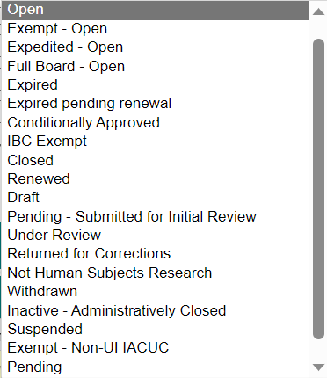

- Position updates from OSP (& introduce new team members if available)
  - Shannon Shumard new position in Cost Accounting Unit
  - Bryon Cavolo new position in Cost Accounting Unit
  - LeAnn O’Rourke started in Financial Unit
  - Patrick Grace started in Contract Review Unit
  - Chelsea Franklin new position in Pre Award – admin to be hired soon.
  - Post award will soon be just Sami and Vicki – please exercise patience.

- Other and requests for future topics
  - ORCID update – working with Library and IIDS/RCDS re: single sign-on process
  - SciENcv requirements for NSF starting 10/23/23 – must use this format for biosketches and current and pending to NSF. ORCID feeds to SciENcv though – will cut down on manual inputs.

- Follow-up: please review TDX status, updates, or VERAS status before sending follow-up – we are getting a lot of repeat requests and questions that are answered in the VERAS status and/or TDX feeds or emails.

