Attach an Application when an Amendment is returned for corrections

Use the My Workspaces drop down menu to select “Study Assistant”.
Scroll down to IRB Studies.
Find the study you want to modify (it will have a red box that says “Returned for Corrections”) and then select the pencil and paper icon in the “Click to open Study Dashboard” column next to the study.
On the right-hand side under “Outstanding Submissions” select the “Respond to Review” button next to the study you want to work on.
Begin in Section 1.0 and respond to each stipulation by selecting the radio button for “Yes” and then typing your response in the text box. You should describe the changes you are making and where they will be located.
Select “Save Section”.
If you need to add new documents scroll down to Section 1.2 and add documents.
If you need to add a new application, select “Review/Attach” next to the IRB Amendment – Protocol Modification.
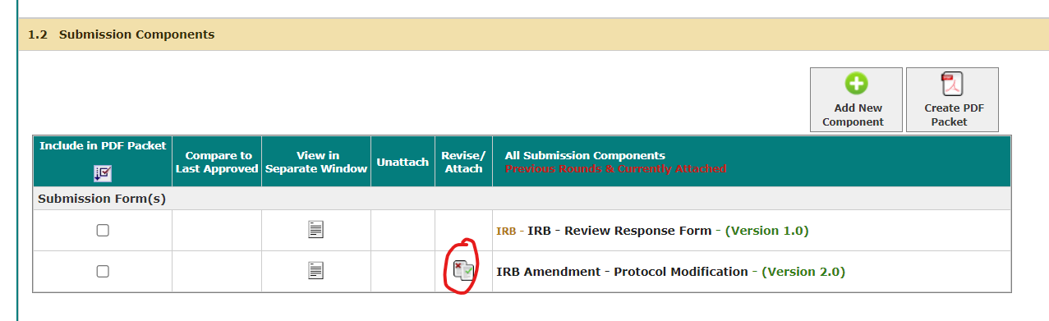
In the left-side menu “Section view of Form”, select “3.0 Application and Document Revisions”.
In Section 3.1, select “Click here to create a revision to the attached application.”
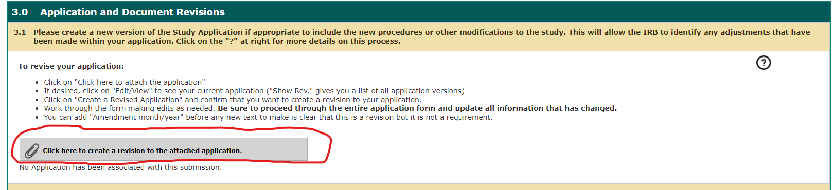

Section the icon under “Create a Revised Application”.
Attach the next sequential study application version (Example: 1.3 instead of 1.2) and then select “Save Attachment”.
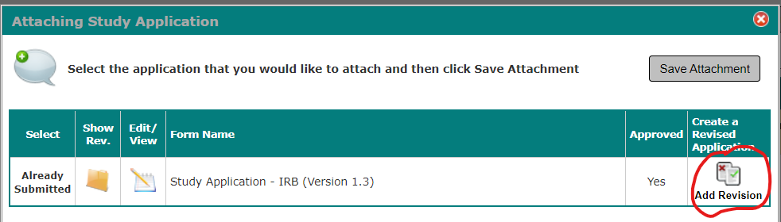
Select “Confirm” in the pop up box.
Begin making your edits. As you update each page, select “Save and Continue to Next Section”. On the left hand side of the page will be a “Section view of the Application”. Update each section that you need to change. Select “Save and Continue to Next Section” until you have completed all of the updates.
You will be returned to the IRB Amendment – Protocol Modification when you have finished the updates to the application.
In Section 3.2 and 3.2 add new consent or other documents if needed. When finished, select “Save and Continue to Next Section”.
Select “Send Submission”.
If you are the PI you will be directed to the IRB Principal investigator Agreement for approval and a final sign off. If you are not the PI, please notify the PI that it is ready for their final signoff.

