Analytical Sciences Lab
Emergency Response Plan Holm Research Center
June 29,2009

Table of Contents Page

Plan Overview 1

Building Location and Description 2

Reporting an Emergency 2

Emergency Procedures

Building Evacuation Procedures 3

Campus Evacuation/Closure Procedures 6

Medical Emergency Procedures 6

Fire or Explosion Emergency Procedures 7

Hazardous Materials Emergency Procedures 7

Power Outage Procedures 8

Procedures for Responding To Criminal Activity or Violence 8

Bomb Threat Procedures 8

Terrorist Events 9

Active Shooter / Hostage (“Lockdown”) 11

I. Plan Overview

Everyone in a University of Idaho facility – students, faculty, staff, and visitors – must take appropriate and deliberate action when an emergency strikes a building, a portion of the campus, or the entire University of Idaho community. Careful planning, with an emphasis on safety, can help the University handle crises and emergencies with suitable responses, and may save lives. Supervisors are responsible for ensuring all employees are familiar with and will follow this emergency plan. Where appropriate, unit members will be assigned emergency preparedness and response duties to assist in the implementation of our emergency response plan.

Follow these important steps when there is an emergency:
- Confirm and evaluate conditions.
- Report the incident immediately.
- Follow instructions from emergency staff precisely.
- Follow this emergency response plan.
- Issue clear and consistent emergency notifications. Use all available communication tools.
- If there is no power and/or telephone systems are not functioning, emergency communications will be profoundly restricted and the University of Idaho will use messengers, radios and cellular phones.

This Emergency Response Plan is an adjunct to the University of Idaho Emergency
Management Plan, as are the other unit plans. Together they provide the overall emergency plan for the entire campus. The University of Idaho Emergency Management Plan establishes an emergency leadership and organizational structure. A copy of this plan can be found at http://www.uidaho.edu/safety/.

The primary goals of the University of Idaho Emergency Management Plan are:
- To protect lives, intellectual property and facilities.
- To prevent or minimize the impact of emergencies and to maximize the effectiveness of the campus community in responding to inevitable occurrences.
- To provide for the continuity of campus operations in pursuit of the University of Idaho’s mission of teaching, research and extension.

Emergency Occurrence After Hours

There is a significant chance an emergency may occur outside regular University of Idaho office hours.

While the structure of this plan remains precisely the same, its implementation may vary depending upon available resources and manpower until the proper officials can be notified. Until that time, the individuals assuming the most responsibility will be those officials/individuals of highest rank who are available at the time. These individuals should seek to follow, as nearly as possible, the guidelines of the plan while simultaneously making an effort to notify University of Idaho administrators of the situation so as to obtain verification or advice on their actions.

Submittal and Review

Each unit must submit an initial copy of their completed Emergency Response Plan to the Risk Management Office. Thereafter, the plan should be reviewed annually. If the plan is changed, an updated copy of the Emergency Response Plan must be sent to the Risk Management Office by October 1.

II. Building/Location Description

Holm Research Center
The building is located at 2222 West 6th street. The two floors, one stairwell and one elevator. The stairwell is located on the northeast corner. The elevator is located in the northeast stairwell .The building is equipped with an automatic alarm. The building is occupied by three separate organizations: 1. Analytical Sciences Lab., 2. USDA ARS, 3. Animal and Veterinary Sciences (NERL)

III. Reporting an Emergency

A. Step 1
- Call 911. In most cases, such as a fire, hazardous materials release, terrorist/criminal activity, or earthquake, the appropriate number to call is 911.
- Or, if it is a utility failure or utility problem, call Facilities at 885-6246.

B. Step 2
Notify:
- Steve McGeehan 885-7900
- Greg Bohach 885-6666
- John Hammel 885-6681

C. Step 3
Notify:
- Facilities 885-6246
- Environmental Health and Safety 885-6524
- Risk Management 885-7177

IV. Emergency Procedures

A. Building Evacuation Procedures

Title: Laboratory Emergency Evacuation Plans

Contributors: G. Möller, D.W. Warner

Approved: _________________ ___Chief Chemist__ __________
Kim Anderson, Ph.D. Title Date

Approved: _________________ _Technical Director_ __________
Gregory Möller, Ph.D. Title Date

Filepath: P:\SOP\SAFETY\EVACU.DOC
Status: This document is considered current standard procedure of the Analytical Sciences Laboratory when management approval is documented by signature above. This Standard Operating Procedure is effective on the date of approval signature and supersedes all other versions until historically archived by the QAU as indicated below.

Archived: _________________ ________________ __________
Signature Title Date

Abstract:
The evacuation plan for ASL is discussed.

I. In the event of an evacuation from the Holm Research Center, the following plan will be implemented:

A. Labs and offices will be vacated in an orderly fashion.

B. The doors and windows should be closed to minimize fire spread if time permits.

C. An assigned person(s) will check for anyone left behind and close all of the doors after making the check. Do not lock the doors.

D. All personnel shall proceed out to the parking lot on the WEST side of the building.

E. An assigned person(s) will then take a head count to further ensure that everyone has safely vacated.

F. If anyone is missing, do not attempt to return to the lab! Contact fire fighters or police at the scene and tell them the person's name and the room number of the lab (or the last place the person was seen).

- STAY TOGETHER and listen for further instructions. DO NOT leave the premises until told to do so.
- 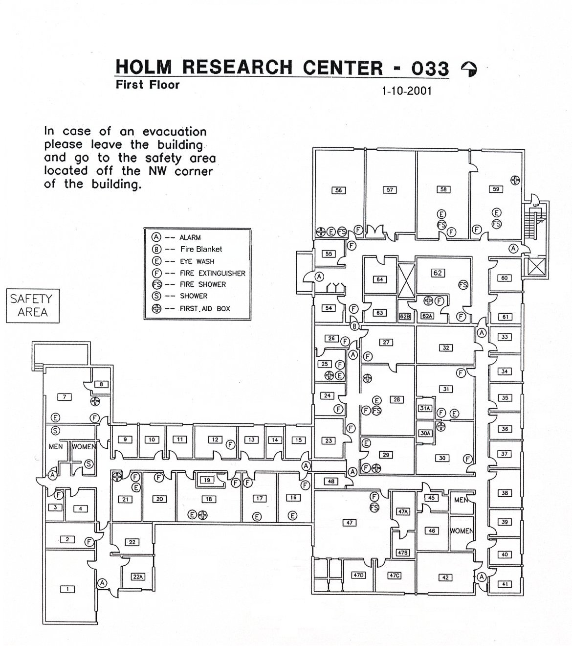

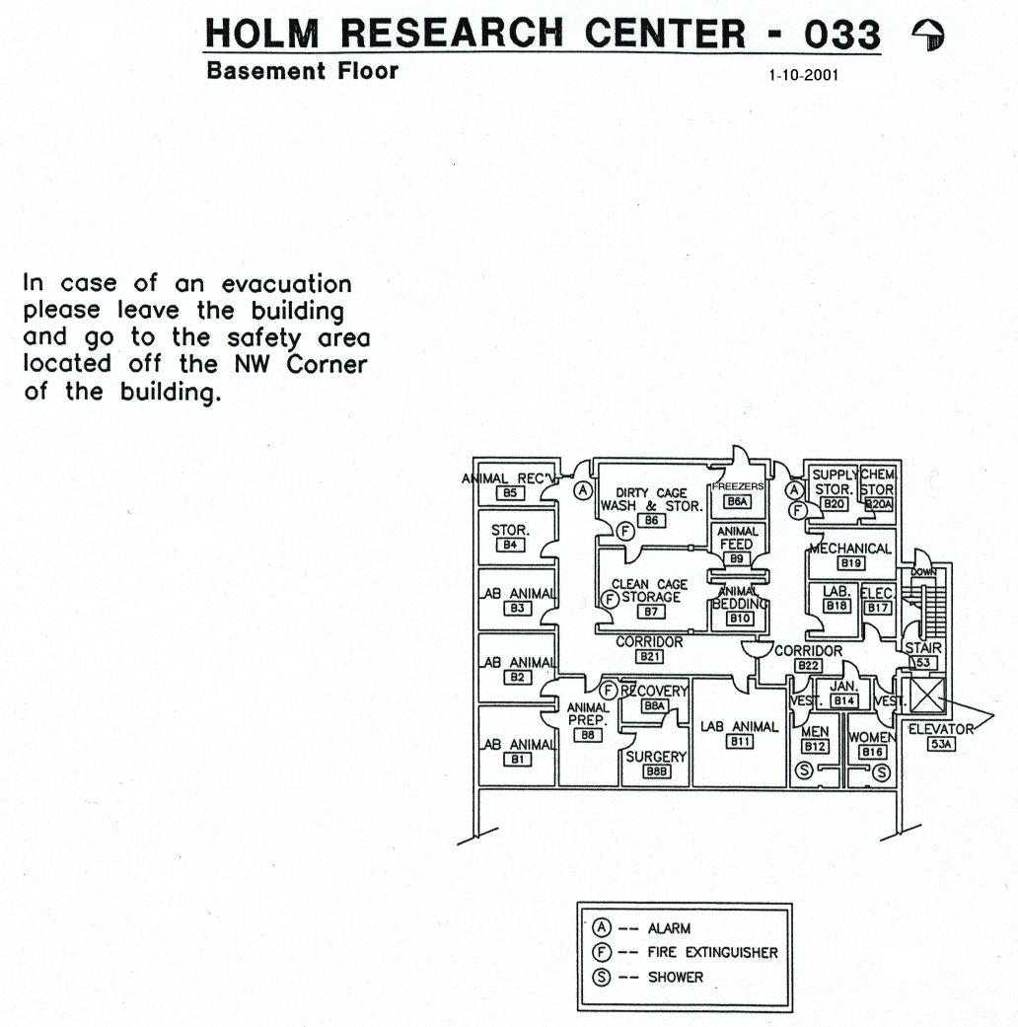

B. Campus Evacuation/Closure Procedures

If it is determined that a campus evacuation/closure is necessary, all units will be notified by the emergency personnel or senior administration of the nature of the evacuation/closure, where to evacuate to (usually to home), and when it is safe to return to the campus. The Technical Director will ensure that all occupants are informed of the evacuation/closure and where to go. The Technical Director will use the phone list to update and distribute information of the emergency as needed to employees.

C. Medical Emergency Procedures

Title: Emergency Medical Care

Contributors: G. Möller, D.W. Warner

Approved: _________________ ___Chief Chemist__ __________
Kim Anderson, Ph.D. Title Date

Approved: _________________ _Technical Director_ __________
Gregory Möller, Ph.D. Title Date

Filepath: P:\SOP\SAFETY\MED.DOC
Status: This document is considered current standard procedure of the Analytical Sciences Laboratory when management approval is documented by signature above. This Standard Operating Procedure is effective on the date of approval signature and supersedes all other versions until historically archived by the QAU as indicated below.

Archived: _________________ ________________ __________
Signature Title Date

Abstract:
The laboratory medical protocol is presented in accordance with UI policy.

I. In a medical emergency, call 911 immediately. If there is concern over billing and this concern raises doubts as to whether to call an ambulance, ALWAYS CALL THE AMBULANCE. The University of Idaho Risk Management Office will pay for the ambulance call. The ambulance crew responding will transport the employee to the most appropriate emergency medical facility.

II. University of Idaho Personnel:

A. Reporting Accidents/Incidents: University of Idaho personnel should promptly report all accidents to their immediate supervisor for evaluation and investigation, whether the event causes injury or illness and/or associated lost-time from work (accident) or not (incident). Timely reporting of incidents as well as accidents will allow supervisors to initiate follow-up procedures, ensuring appropriate medical treatment is made available and that necessary corrective actions are taken and communicated to other employees. If an accident or incident requires medical treatment and/or there is the possibility that medical treatment will be necessary in the future, and/or the accident causes lost-time from work, the individual must fill out a Worker's Compensation form. Regardless of the magnitude of the accident, it is good practice to fill out a Worker's Compensation form. Also, the supervisor must promptly report all accidents and incidents to the UI Safety Office (5-6524). For accidents or incidents requiring Worker's Compensation forms, the supervisor must report the accident or incident as soon as possible following the related event, but no later than 10 calendar days from the date they are made aware of the event. See the attached Safety Office packet for more information on reporting procedures and Worker's Compensation forms.

B. Worker's Compensation: Persons who are unable to perform their normal job duties because of injury, should inform their supervisor and the UI Safety Office (5-6524). The UI Safety Office will direct the individual to personnel who handle Worker's Compensation claims. For more information on Worker's Compensation, sample Worker's Compensation claim forms, supervisor report forms, and accident witness report forms, see the attached Safety Office packet.

III. Student Accident Response: See the attached Safety Office packet for student accident response procedures.

- Protect victim from further injury by removing any persistent threat to the victim. Do not move the victim unnecessarily. Do not delay in obtaining trained medical assistance.
- Provide first aid until help arrives if you have appropriate training and equipment.
- Send someone outside to escort emergency responders to the appropriate location.

Title: First Aid Protocol

Contributors: G. Möller, D.W. Warner

Approved: _________________ ___Chief Chemist__ __________
Kim Anderson, Ph.D. Title Date

Approved: _________________ _Technical Director_ __________
Gregory Möller, Ph.D. Title Date

Filepath: P:\SOP\SAFETY\1ST_AID.DOC
Status: This document is considered current standard procedure of the Analytical Sciences Laboratory when management approval is documented by signature above. This Standard Operating Procedure is effective on the date of approval signature and supersedes all other versions until historically archived by the QAU as indicated below.

Archived: _________________ ________________ __________
Signature Title Date

Abstract:
The first aid protocol for the University of Idaho Analytical Sciences Laboratory is presented.

I. Major Injuries - Call 9-911 to obtain emergency medical assistance in any case of serious injury or life threatening illness. If you are uncertain about the seriousness of an injury call 9-911. Do not move a seriously injured person who is not in some immediate danger from fire or other hazard. Moving an injured person can cause additional injuries and is only justified if you are certain that they face immediate harm if they are not moved. Emergency response by ambulance and fire personnel on the UI campus will be rapid. If an accident victim requires emergency first aid to save their life and you have received first aid training then you should perform the procedures you believe are necessary. These life saving procedures might include stopping profuse bleeding, CPR, or Heimlich maneuver for a choking victim.

II. Minor Injuries - Minor injuries may be treated with a first aid kit located in rooms #28 and #56, (see emergency apparatus locations diagram) All injuries must be reported to the supervisor to determine if further treatment is necessary.

III. Training Requirements and Equipment - See the attached document (First Aid: Training Requirements & Equipment) for information regarding first aid training requirements and equipment.

- Location of first aid kit(s):
a. room 7
b, room 18
c. room 29
d. room 28
e. room 25
f. room 56

D. Fire or Explosion Emergency Procedures

Title: Laboratory Fire Safety Protocol

Contributors: G. Möller, D.W. Warner

Approved: Chief Chemist
Steve McGeehan, Ph.D. Title Date

Approved: Technical Director
Gregory Möller, Ph.D. Title Date

Filepath: P:\SOP\SAFETY\FIRE.DOC
Status: This document is considered current standard procedure of the Analytical Sciences Laboratory when management approval is documented by signature above. This Standard Operating Procedure is effective on the date of approval signature and supersedes all other versions until historically archived by the QAU as indicated below.

Archived:
Signature Title Date

Abstract:
The ASL fire policy is presented.

I. Fires must be reported to the Moscow Volunteer Fire Department as soon as they are discovered by activating a fire alarm. For very small fires, lab personnel should extinguish the fire using a fire extinguisher or by covering the container of flammable material as appropriate. For the location of fire extinguishers and fire alarms see the emergency apparatus location diagrams presented in Part IV below.

Common sense and good judgment are critical. If the fire cannot be controlled by laboratory staff, time lost attempting to fight it could be disastrous. It is important to consider the size of the fire, the type of material burning and fuels in the vicinity.

II. An important consideration is the probability of toxic fumes, reduced oxygen supply in the room or explosion of the material burning or adjacent material. It is critical the lab personnel not overestimate their ability to fight large fires. For all fires notify the Technical Director and Group Leaders as soon as possible after activating a fire alarm.

III. In the event of a laboratory evacuation, all laboratory personnel are required to assemble in the WEST parking lot of the Holm Research Center. Doors and windows should be closed to minimize fire spread if time allows.
See SOP.70.100.xx Laboratory Emergency Evacuation Plans for instructions on evacuating the building.

IV. Emergency Apparatus Locations: Holm Research Center

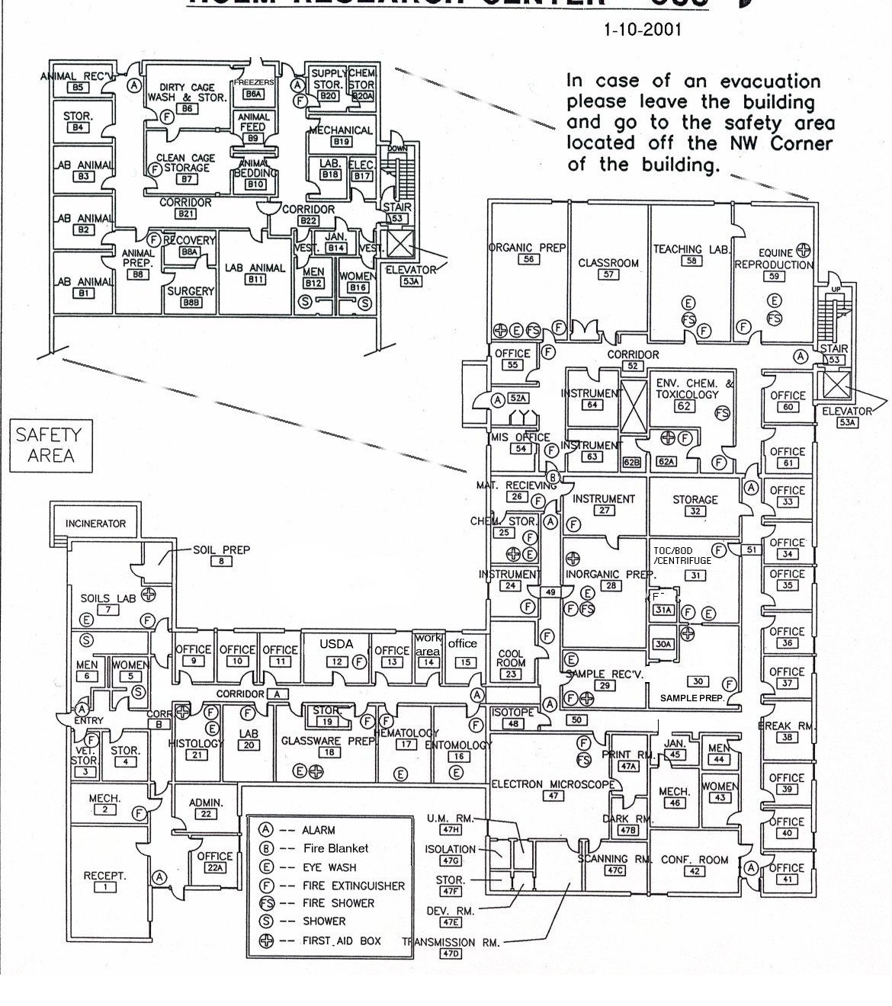

E. Hazardous Materials Emergency Procedures

Title: Guidelines for Chemical Spill Control

Contributors: G. Möller, D.W. Warner

Approved: _________________ ___Chief Chemist__ __________
Kim Anderson, Ph.D. Title Date

Approved: _________________ _Technical Director_ __________
Gregory Möller, Ph.D. Title Date

Filepath: P:\SOP\SAFETY\CHEM.DOC
Status: This document is considered current standard procedure of the Analytical Sciences Laboratory when management approval is documented by signature above. This Standard Operating Procedure is effective on the date of approval signature and supersedes all other versions until historically archived by the QAU as indicated below.

Archived: _________________ ________________ __________
Signature Title Date

Abstract:
Items of concern and the recommended safety practices are discussed concerning chemicals spills in the laboratory.

I. When 1 pint or more of a hazardous substance or any amount of an extremely
toxic substance is spilled, call Emergency Assistance (9-911) and the UI Safety Office (5-6524), in that order. Evacuate the room, close the door, and wait for emergency personnel.

II. If the substance spilled is flammable, remove all ignition sources, if possible, before sealing the room.

III. All contaminated clothing must be removed immediately. Clothes must be
laundered before reuse or disposed of as hazardous waste.

IV. In case of chemical contact with skin or eyes, flood the affected area immediately with water; continue for at least 15 minutes. Seek medical assistance at Gritman Hospital for skin irritations, contact with an extremely toxic substance, or any eye injury.(NOTE:Staff are not accepted at Student Health Services)

V. Small spills (1 pint or less) may be cleaned up by laboratory personnel. It is good laboratory practice to keep spill absorbents on hand
A. Most strong acids may be absorbed and then neutralized with aqueous
solutions of sodium bicarbonate, calcium hydroxide (slaked lime), or sodium carbonate (soda ash). VWR also sells NEUTRASOL Low, Cat. No. JT4455-5, for controlled clean-up of acid spills. (Note: Do not attempt to absorb hydrofluoric acid. Skip this step and neutralize immediately.)
B. Caustic solutions and flammable liquids may be absorbed with an inert
absorbent. NEUTRACIT-2 is a caustic neutralizer sold by VWR. Its Cat. No. is JT4470-5 (1200g) and JT4470-8 (50lbs.). Spill pillows are used to abosorb flammable liquids. These spill pillows are located in RM 56 under FH #6.
C. Do not attempt to blot cryogenic liquid spills. Evacuate the area and let
the spill take it's natural course.
D. Formaldehyde spills may be absorbed with an inert absorbent (Vermiculite).
E. Solid spills are not usually emergencies. If the material spilled is toxic, use dampened cloths or paper towels to transfer it to plastic bags. Brushing dry material may cause dust to become airborne.

VI. All absorbed spill material must be collected in double plastic bags or plastic
containers with secure lids and disposed of as hazardous waste (call the UI Safety Office 5-6524 for pickup). If the absorbent has been used for a flammable or volatile compound, it must be stored in a well-ventilated area away from sources of ignition while awaiting pickup. A fume hood is a good temporary storage area.

VII. A good, general-purpose spill absorbent is the spill pillow available from VWR
(Cat. No. 56616-352). Spill cleanup kits for solvents, acids, bases (caustic), mercury, hydrofluoric acid, and others are commercially available from sources such as VWR, J.T. Baker and Lab Safety Supply. Vermiculite, which is stored in the large plastic barrel outside of room 27 is also availble for chemical cleanup, it is absorbent, but does not contain vapors well. It is very cheap, and thus is recommended for nontoxic spills.

VIII. Information on the proper procedures for handling, storage, and disposal of most common laboratory chemicals is available from the UI Safety Office at 5-6524.

F. Power Outage Procedures

Title: Guidelines for Power Failure and Recovery

Contributors: D.W. Warner

Approved: ___________________ Chief Chemist
Steve McGeehan, Ph.D. Title Date

Approved: Technical Director
Gregory Möller, Ph.D. Title Date

Filepath: P:\SOP\SAFETY\POWER.DOC
Status: This document is considered current standard procedure of the Analytical Sciences Laboratory when management approval is documented by signature above. This Standard Operating Procedure is effective on the date of approval signature and supersedes all other versions until historically archived by the QAU as indicated below.

Archived:
Signature Title Date

Abstract:
Instructions are given for procedures to follow during and immediately after a power outage.

I. Procedures to follow during a power outage:
- If an outage is more than momentary, turn off any equipment that may have been running such as blenders, homogenizers, hot plates, heating mantles, and any others that draw large amounts of power, have moving components (excluding clocks and other low power, nonhazardous movement) or need supervision during operation.
- Computers should also be turned off to prevent damage when power is restored.
- Close hood sashes and leave the laboratories; close individual laboratory doors. Do not leave building/adjoining parking area without informing supervisor.
D. Consideration should be given to shutting down the computer network, as the UPS will last only 10 minutes at best.

- When power returns:
- Do not enter laboratory areas until at least 15 minutes after the power has been restored in order to allow time for venting in hoods and for establishing air circulation in the lab.
- Restart computers.
- Restart ICP/MS pumps.
- Ensure that GC/MSDs are pumping down properly.
- Observe the temperature in the GC/MSD room (56). If the air conditioner is turned on but not functioning, turn it off at the circuit breaker (behind the door) for ten (10) minutes and then turn it back on. If this does not restore proper operation, inform UI Facilities Management.
- Observe all freezers and refrigerators for proper operation.
- Check chemical hoods for proper operation.
- Be aware of other occurrences in and around the laboratory that are not usual or expected, and report these to a supervisor or safety personnel.

Documentation of Power Outages
Record the occurrence of power outages in the appropriate equipment maintenance logbooks. Record the date and time period, if known, and any comments regarding instrument operation.

G. Procedures for Responding To Criminal Activity or Violence

- Attempt to remove yourself from any danger.
- Notify Moscow Police by calling 911. Try to call from a safe location if possible.
- If possible, provide the police with the following information:
- Location of crime
- Nature of crime and specifics (number of people involved, any weapons, etc.)
- Any injuries
- Description of suspect(s) (height, weight, sex, race, clothing, hair color etc.)
- Direction of travel of suspects
- Description of any vehicles involved in the crime
- DO NOT pursue or attempt to detain suspects.

H. Bomb Threat Procedures
- Obtain and review the Bomb Threat Checklist (available from the main office College of Agriculture).
- If you receive a bomb threat:
- Check the exact time.
- Listen carefully to the caller's voice.
- Write down the caller's exact words.
- Use the Bomb Threat Checklist.
- Ask questions, particularly about:
  - Location of device,
  - Time of detonation, and
  - Type of device.
- Listen for background noises.
- Note the time the caller hangs up.
- Hang up the phone. Immediately, before the next call comes in:
  - Pick up the phone and dial *57 (This will start a trace on the call. There may be a cost for this service, it is okay to accept the cost.),
  - Listen and write down what the recorded message says,
  - Hang up again, pick up the phone and dial *69 (This will give the phone number of the last call received, if available.), and Listen and write down what the recorded message says.
- Call the Moscow Police Department (911) and report:
- Your name.
- Location and telephone number you are calling from.
- The situation.
- Location of the device, if known.
- Time it is set to detonate, if known.
- Type of device, if known.
- Exact time you received the call.
- The information you received after you dialed *57 and *69.
- Any other information on the Bomb Threat Checklist.
- Inform your supervisor.

I. Terrorist Events

- Recognizing a Potential Terrorist Event

It is difficult to know with certainty in what form a terrorist event will take place. It could be an obvious event involving an explosion and release of hazardous materials, or it could involve a covert method, such as mailing letters or packages containing hazardous materials.

The following are guidelines for generic suspicious activities that should be reported to the Moscow Police Department at 882-2677 or, if life threatening, at 911:

Anonymous tips, phone calls or notes indicating threatening events.
People watching officials or offices.
Unidentified or unattended packages left in or near offices.
Requests for plans, blueprints, or specifications for buildings by people who have no reason for this information.
People in places where they do not belong.
Packages or heavy mail which have a peculiar odor or appearance.
Confrontations with angry, aggressively belligerent or threatening persons.
Extremely threatening or violent behavior by co-workers who indicate they may resort to revenge or more violence.
Securing and Accounting for Hazardous Materials

The use of hazardous materials at the university requires safeguards and increased security. However remote the possibility, we should prevent the unintentional removal of biological agents, radioactive materials, and hazardous chemicals. By using common sense and the following steps, we can greatly reduce the potential for problems:

Do not leave laboratories, or other areas where hazardous materials are present, open and unattended. If you leave the area, make sure the door is locked.

When not in use, return hazardous materials to their proper storage area. Storage areas in unattended spaces should be locked.

Maintain an inventory of hazardous materials and routinely check these materials.

Do not allow unauthorized personnel into your work space. Question people who enter your work space and who are unfamiliar to you.

If you notice any hazardous materials missing or believe they have been stolen, please contact the Moscow Police Department at 882-2677 and the Environmental Health and Safety Office at 885-6524.

Guidelines for Screening Suspicious Packages and Letters - Concerns for Biological or Chemical Threats.

NOTE: Due to the mission of ASL, packages which may be leaking blood or other biological fluids are to be expected and the use of gloves and other protective gear is expected. Although any threatened use of a biological or chemical agent must be treated as though it is real, experience has demonstrated that these are likely to be a hoax. If the suspected biological agent is reported as anthrax, be assured that it is NOT generally contagious (i.e., spread from person to person) and that treatment is available and effective if administered before the onset of symptoms.

Common features of suspect packages or letters are:
- There may be liquid leaking from package.
- They tend to have hand-applied postage.
- They have excessive postage.
- They are addressed to a position, not a person.
- There may be no return address.
- They are often hand written or have a poorly typed address.
- They tend not to be in business format envelopes.
- There may be misspelling of common words.
- They may have restrictive markings such as "Confidential", “Personal", etc.
- They may have excessive weight and/or the feel of a powdery or foreign substance.
- There may be foreign post marks and/or writing.
- The source of the letter/package is not recognized by recipient/addressee.

If you believe you have received a suspect package or letter, you should:

NOT open the letter or package.

Contact Moscow Police at 882-2677.

Remain at the site until police arrive with instructions.

If you inadvertently open a suspect package/letter or if it is leaking liquid or an unknown substance, you should:

Immediately set the item down gently at the location where it was opened.

Contact Moscow Police at 911.

All potentially exposed persons should leave the area and wash exposed skin with soap and water.

Return to an area within the building adjacent to the initial exposure and wait for police (For example, a hallway outside the original room).

Do not allow others into the area. If anyone enters the area, they should stay in the area until instructed to leave by Moscow Police.

Remember that this is NOT a medical emergency yet, but it is a potential contamination problem.

This is also a potential crime scene - preserve evidence and pay attention to what you have seen or done.

You should NOT do the following:

Pass the letter or package to others to look at.

Disturb any contents in the letter or package. Handling the letter/package may only spread the substance contained inside and increase the chances of it getting into the air.

Ignore the threat; it must be treated as real until properly evaluated.

Leave the building until instructed to do so.

- Guidelines for Screening Suspicious Packages and Letters – Concerns for Explosive Devices

A suspicious package or letter may have any of the features listed above for suspicious packages and letters that may contain biological or chemical materials, including the following:
- They may have bumps, wires, or pieces of metal exposed.
- They may be heavy.
- They may have an excessive amount of securing material, such as tape, string, etc.

If you suspect that a package or letter contains an explosive device, you should:

Not move or open the package or letter.

Not let other people inspect or handle the package or letter.

Immediately evacuate the immediate and surrounding area.

Call 911 from a safe location.

J. Active Shooter or Hostage (Lockdown)

An active shooter is a person or persons who appear to be actively engaged in killing or attempting to kill people in populated areas on campus. Active shooter situations are dynamic and evolve rapidly, demanding immediate response by the community and immediate deployment of law enforcement resources to stop the shooting and prevent harm to the community. Be aware that the 911 system may become overwhelmed in this type of incident.

Guidelines

In general, how you respond to an active shooter will be dictated by the specific circumstances of the encounter. If you find yourself involved in an active shooter situation try to remain calm and CALL 911 as soon as possible.

If an active shooter is outside your building or inside the building you are in, you should:
- Try to remain calm
- Try to warn other faculty, staff, students and visitors to take immediate shelter
- Proceed to a room that can be locked or barricaded
- Lock and barricade doors or windows
- Turn off lights
- Close blinds
- Block windows
- Turn off radios or other devices that emit sound
- Keep yourself out of sight and take adequate cover/protection, i.e. concrete walls, thick desks, filing cabinets, or any other object that will stop bullet penetration.
- Silence cell phones
- Have ONE person CALL 911 and provide:
  - “This is the University of Idaho (give your location) and we have an active shooter on campus, gunshots fired.”
  - If you were able to see the offender(s), give a description of the persons(s) sex, race, clothing, type of weapon(s), location last seen, direction of travel, and identity – if known.
  - If you observed any victims, give a description of the location and number of victims.
  - If you observed any suspicious devices (improvised explosive devices), provide the location seen and a description.
  - If you heard any explosions, provide a description and location.
- Wait patiently until a uniformed police officer, or a university official known to you, provides an “all clear”.
- Unfamiliar voices may be an active shooter trying to lure you from safety; do not respond to voice commands until you can verify with certainty that they are being issued by a police officer or university official.
- Attempts to rescue people should only be attempted if it can be accomplished without further endangering the persons inside a secured area.
- Depending on circumstances, consideration may also be given to exiting ground floor windows as safely and quietly as possible.
- If a lock down is implemented, no one will be allowed to enter or leave the building.

If an active shooter enters your office or classroom, you should:
- Try to remain calm
- Try not to do anything that will provoke the active shooter
- If there is no possibility of escape or hiding, only as a last resort when it is imminent that your life is in danger should you make a personal choice to attempt to negotiate with or overpower the assailant(s)
- Call 911, if possible, and provide the information listed in the previous guideline
- If the active shooter(s) leaves the area, barricade the room, or proceed to a safer location

If you are in an outside area and encounter an active shooter, you should:
- Try to remain calm
- Move away from the active shooter or the sounds of gunshot(s) and/or explosion(s)
- Look for appropriate locations for cover/protection, i.e. brick walls, retaining walls, large trees, parked vehicles, or any other object that may stop bullet penetration
- Try to warn other faculty, staff, students and visitors to take immediate shelter
- CALL 911 and provide the information listed in the first guideline

What to do if taken hostage
- Be patient. Time is on your side. Avoid drastic action.
- The first 45 minutes are the most dangerous. Be alert and follow instructions.
- Don’t speak unless spoken to and then only when necessary.
- Avoid arguments or appearing hostile. Treat the captor with respect. If you can, establish rapport with the captor. It is probable that the captors do not want to hurt anyone. If medications, first aid, or restroom privileges are needed by anyone, say so.
- Try to rest. Avoid speculating. Expect the unexpected.
- Be observant. You may be released or escape. You can help others with your observations.
- Be prepared to speak with law enforcement personnel on the phone.

What to expect from responding police officers

The objectives of responding police officers are:
- Immediately engage or contain the active shooter(s) to stop life threatening behavior
- Identify threats such as improvised explosive devices
- Identifying victims to facilitate medical care, interviews and counseling
- Investigation

Police officers responding to an active shooter are trained to proceed immediately to the area in which shots were last heard in order to stop the shooting as quickly as possible. The first responding officers may be in teams; they may be dressed in normal patrol uniforms, or they may be wearing external ballistic vests and Kevlar helmets or other tactical gear. The officers may be armed with rifles, shotguns or handguns. Regardless of how the police appear or sound, do not be afraid of them. Do exactly as the officers instruct. Put down any bags or packages you may be carrying and keep your hands visible at all times; if instructed to lie down, do so. If you know where the shooter is, tell the officers. The first officers to arrive will not stop to aid injured people. The first responding officers will be focused on stopping the active shooter and creating a safe environment for medical assistance to be brought in to aid the injured. Keep in mind that even once you have escaped to a safer location, the entire area is still a crime scene; police will usually not let anyone leave until the situation is fully under control and all witnesses have been identified and questioned. Until you are released, remain at whatever assembly point authorities designate.

