Instructions for signing up for Direct Deposit for Travel Reimbursements or Petty Cash:
Go to the Accounts Payable website at http://www.uidaho.edu/controller/accountspay

In the right hand column, under “Direct Deposit Sign Up,” click on “AP and Travel Direct Deposit”

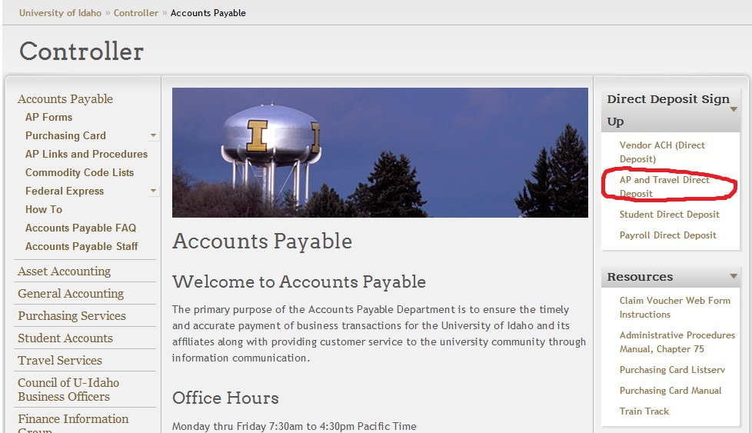

This will take you to a screen in VandalWeb. You will need to enter your VandalWeb login information to proceed.
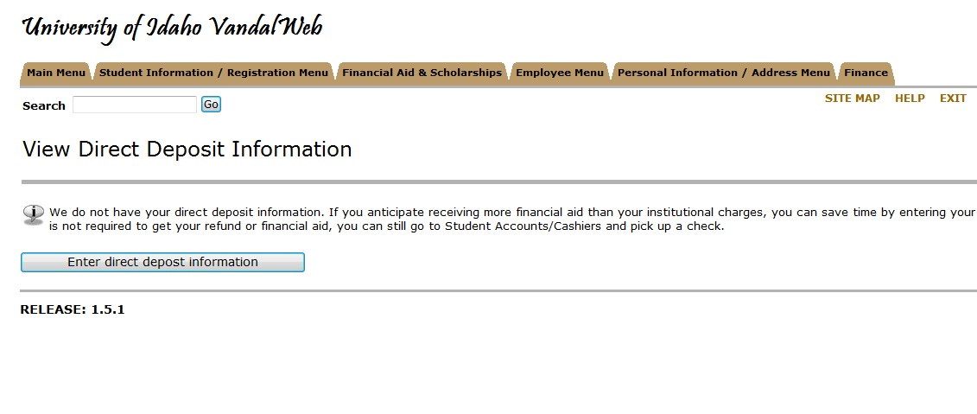
Enter routing information for the bank account where you want to have future reimbursements deposited.

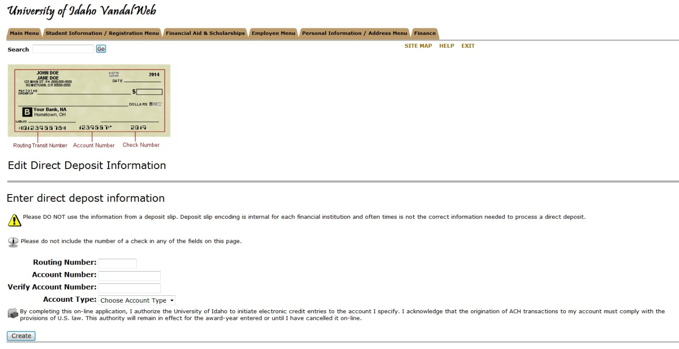

You will need your bank account number and routing number.
Once, you have entered the information, click “Create”.

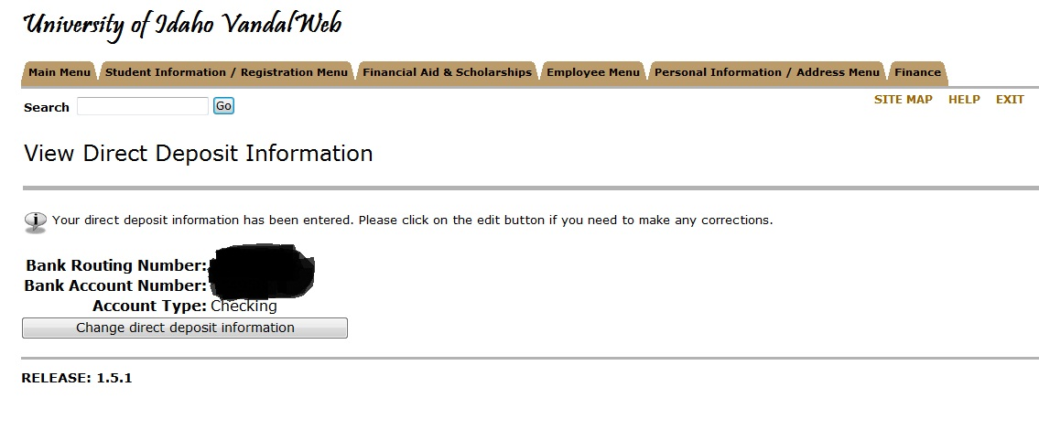
Once your information is entered, you do have the option to change it, if needed.

