Product Name: Sulfuric Acid  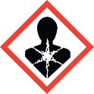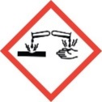 |  | Product Name: Sulfuric Acid  DANGER |  | Product Name:
Product Name: |  | Product Name: |  | Product Name:
Product Name: |  | Product Name: |  | Product Name:
Product Name: |  | Product Name: |  | Product Name:
Product Name: |  | Product Name: |  | Product Name:
Product Name: |  | Product Name: |  | Product Name:
Product Name: |  | Product Name: |  | Product Name:
Product Name: |  | Product Name: |  | Product Name:
Product Name: |  | Product Name: |  | Product Name:
Product Name: |  | Product Name: |  | Product Name:

