Division of Finance
www.uidaho.edu/finance/

REQUEST TO DEPOSIT VENDOR or NON EMPLOYEE ACCOUNTS PAYABLE PAYMENTS

I hereby grant authorization to deposit my vendor or individual check directly to my checking or savings account. I understand that this will take effect within the next 7 days after receiving the information. This authorization will continue indefinitely until I give written notice to discontinue.

_____________________________ _________________________________________________
Vendor/ Individual Name (printed) Vendor/Individual address (printed)

___________________________ _____________________________________________
Day Time Phone Number E-mail Address for remittance information

Savings ________________ OR Checking ________________
(Please check one)
Bank Routing number: _________________________________________________________________________

Bank Account Number:_________________________________________________________________________

___________________________________________________ ____________________________
Signature Date

PLEASE SECURELY ATTACH A VOIDED CHECK

DO NOT USE DEPOSIT SLIPS
(BANK ROUTING INFORMATION MAY NOT BE ACCURATE)

- PROTECT YOURSELF WITH SENSITIVE ACCOUNT INFORMATION!
  - Email this form to:acctpay@uidaho.edu (You are responsible to delete the email from your sent files.)
  - Or Fax to: Accounts Payable, 1-208-885-5417
  - Or bring the form to: Accounts Payable, Bruce Pitman Center, 709 Deacon Street rm 42, Moscow, ID 83844-4244

For questions concerning your banking information or direct deposit setup, please call Accounts Payable at 208-885-5394 or email acctpay@uidaho.edu
HOW TO FIND YOUR ACCOUNT INFORMATION

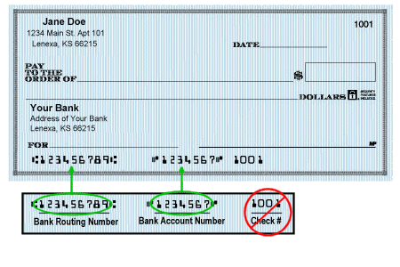
Your bank can also print off a Direct Deposit Form if you do not have checks.

