In order to recruit qualified employees, UI will reimburse newly hired employee’s actual and reasonable moving expenses as a condition of securing his or her employment.

In addition, UI will reimburse actual and reasonable moving expenses for current employees who are relocated from one official station to another within the state for the benefit and convenience of the University.
http://www.sco.idaho.gov/web/sbe/sbeweb.nsf/displayview?ReadForm&L1=Board+of+Examiners&L2=Policies+and+Procedures

Logging Into the UI Moving Expense Program
To login in to Employee Moving Expenses, login to Vandal Web and select Employees > Financial Tasks – Employee Moving Expenses.

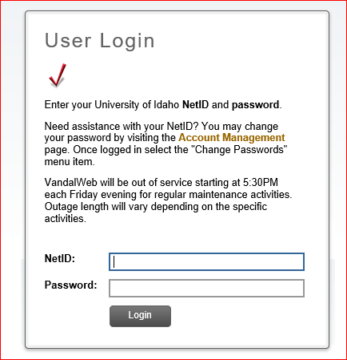

Creating the New Move Record
To qualify for moving reimbursements:
- All moves must meet the IRS Distance Test: the commuting distance must have increased by at least 50 miles one way.

- The maximum moving allowance shall not exceed 10% of the employee’s salary or $15,000 whichever is less. Exceptions may be granted If approved in advance by the VP Finance.

- If more than one member of a household is employed by the UI, only one household allowance is provided and shall be based on the employee with the greater base salary.

- UI will limit total payments to third parties and employees to the allowable moving allowance. Should excess reimbursements occur, employees are required to reiimburse the University within 90 days of the move.

To Start the Moving Process of a New Employee, select Create New Move Records and provide the following information:

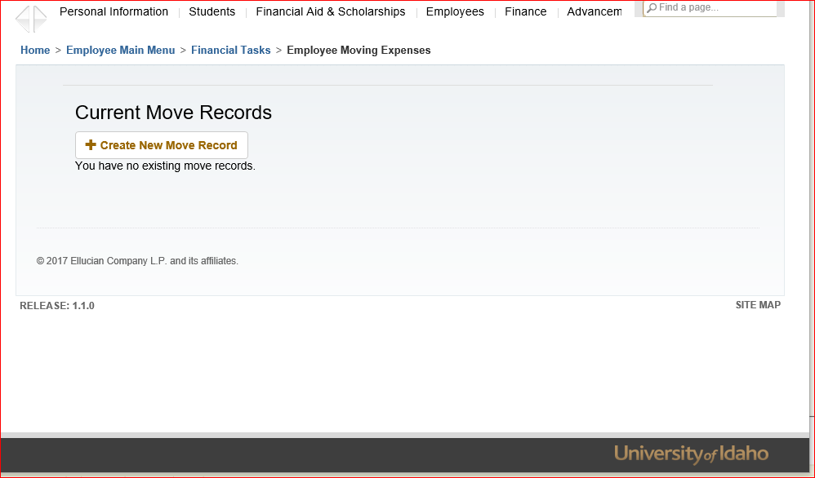

The creation of the Employee Vandal Number is required prior to the Create Move Records. The PCN and Suffix information is a required field.

If the employee is not currently on Banner, the new employee can work directly with Human Resources to create a Vandal Number. Accounts Payable may also be able to assist you with the information.

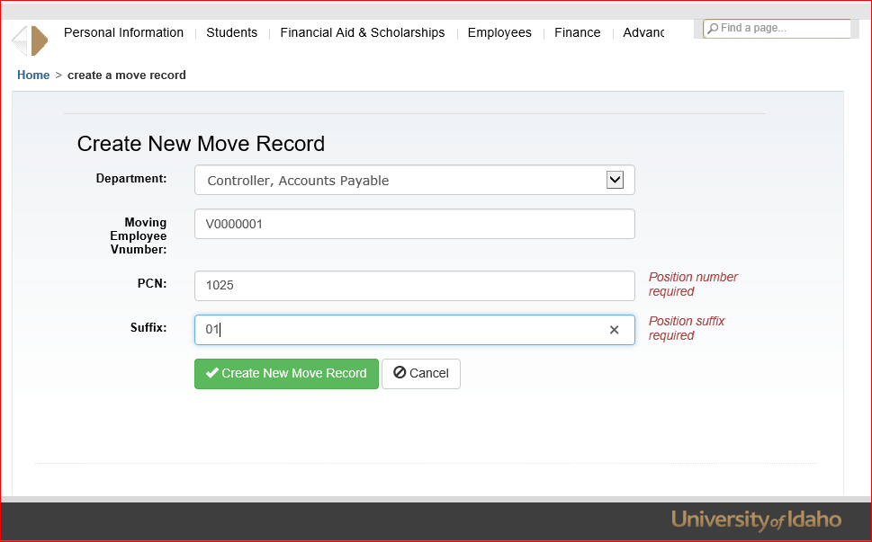

Be sure to enter the new employee’s contact information in case we need to contact them concerning their move or reimbursement.

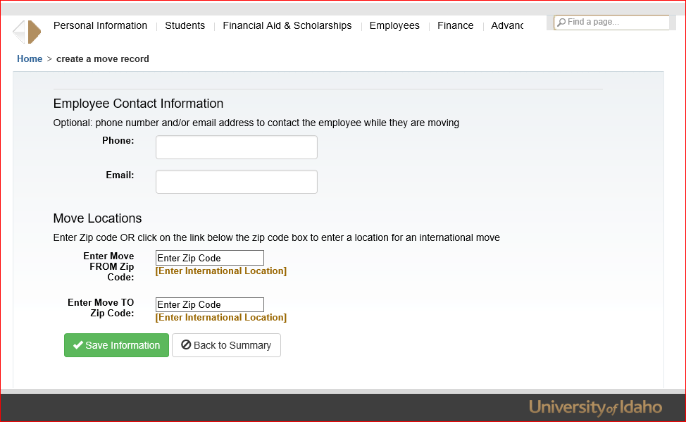

Complete all of the required information and Save Information.

Create a New Moving Expense Claim Voucher
Moving expenses allowable for reimbursement include:

- Actual receipts and expense for moving household goods and personal effects.
- Actual receipts of traveling expenses, including parking fees, tolls paid during the move.
- Transportation of personal vehicles.

Taxable Expenses:
Considered additional income and subject to payroll withholding.

- Mileage reimbursement greater than the IRS Moving mileage allowance.
- Meals or per diem – during the move and while in temporary quarters.
- All expenses reimbursed for pre-move housing trips.
- Temporary household goods storage expenses.

Select the Employee Record – for example Joseph Vandal - you will receive a summary of their information

The Summary lists the available balances remaining that can be expenses. The View More Details, provides a listing of previous documents associated with the Moving Records.

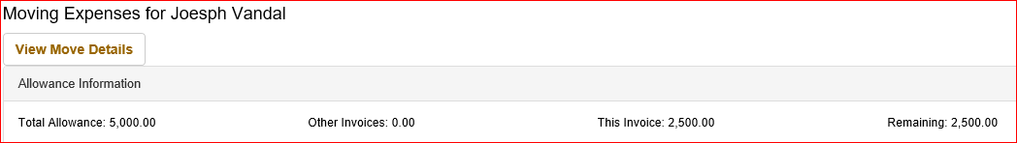

At the bottom of the page, select on Create New Claim Voucher A Banner “I” Invoice Document will be assigned to the Claim Voucher at This point. The I number is viewable on Banner FOIDOCH as “S” status.

Enter information in the Claim Voucher Fields:

- Select Department
- Vendor Payee ID or Individual’s Vandal Number (V#)
Note: If you do not know the Payee ID, the Search Button will allow you to query for the information.
- If the Vendor or individual does not currently exist in Banner or the available address is not correct, contact Accounts Payable for the GID Identification to be created or updated.

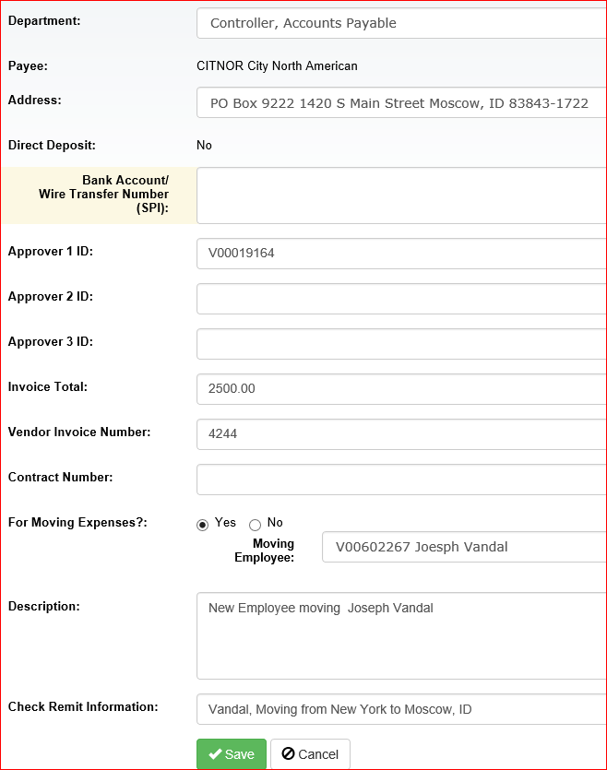

- Select the address for the payment to be mailed.
- The direct deposit indicator advises whether the person will be receiving a check or as direct deposit.
- Enter Approver 1 ID: Approver 1 is a required field, but depending on your college and department, you may need to add additional approvers. (If you do not know their Vandal Number, select the SEARCH button.)
Note: Claim voucher approvals are not forward through the Banner document approvals only the vandal web approvals.
- Enter the Total Amount of the Claim Voucher Payment
- Enter the Vendor Invoice Number: (See Additional Information regarding invoice numbers).
- Enter the Purchasing Services Contract Number if one is available
- Provide a description of the payment; this information will be forwarded directly to the Banner form FOATEXT.
- Enter Check Remit information that will display on the paper check or direct deposit remittance.
- Select Moving Yes or No
- If the Answer is YES, Select the New Employee for the drop down list.
- If the Answer is NO, Continue with the Claim Voucher as usual.

- CLICK on SAVE when finished.

Your screen will now add all information. If any errors occurred, you will not be allowed to move forward. Or if you need to Edit the Header, select Edit the Header and update the information.

Add Accounting Detail
Select Add Accounting Line.

- Select the Moving Expense Commodity Code that best describes the Payment.

- If the Claim Voucher has been selected as Moving Expenses, only the Moving Commodity Code will be available for the selection.
- If the Claim Voucher is not a Moving document, all of the remaining commodities will be available for selection.

Note: The commodity codes are for reporting purposes and are a requirement. (See Additional Information regarding Claim Vouchers)

- If you are using a Budget or Index to pay for the expenditure, Select Budget and continue to complete the information including the amount.

- If you are posting to a General Ledger Account, Select GL Account and enter the Fund and Account Information including the amount.

- If you need to split the accounting, add additional accounting lines that should total the amount listed in the Header Information.

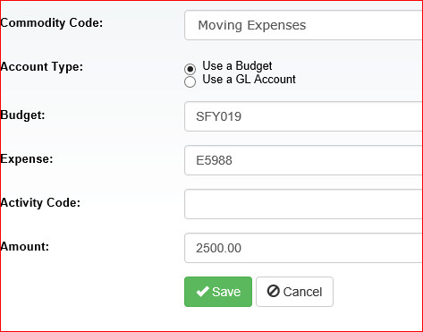

Select Save
It will return you to the Claim Voucher Summary Page

Add comments to identify the individual moving expenses, or attach a summarized spread sheet of the expenses. Please be sure to clearly identifying the amounts and types of expenses.
Identify:
- Whether it is house hunting or during the actual move.
- Fuel receipts indicating which vehicle.
- Lodging or temporary housing and storage.
- Truck Rental and supplies.
The information is necessary to determine the taxable portions of the move to the new employee.

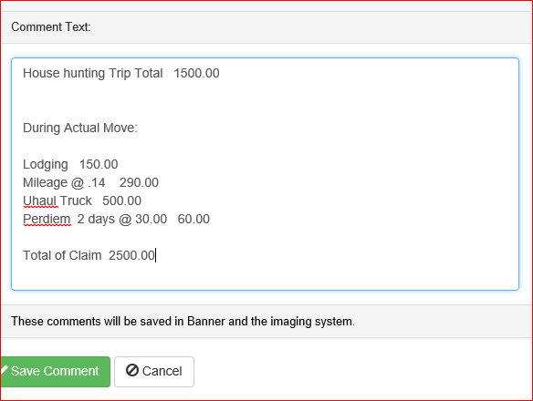

Select Save Comment
It will return you to the Claim Voucher Summary Page

Attach Images: Select Attach Image
Browse to locate the PDF file of the support document to be attached to the Claim Voucher form.

After the form has been located, select UPLOAD to attach it to the Claim Voucher Form

It will return you to the Claim Voucher Summary Page

Select SUBMIT to complete the claim voucher.

Selection: Print Form. Allows you the ability to Print the document for your records, but do not forward it to Accounts Payable; the image within the Claim Voucher Program will be submitted directly to the Document Imaging Program.
Moving Summary: displays the recent payments made to a new employee. By selecting the gold highlights, the document is viewable within the claim voucher program.
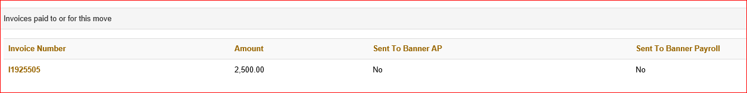

Questions concerning the Payment of Moving Expenses, please contact Accounts Payable at 208-885-5379.

