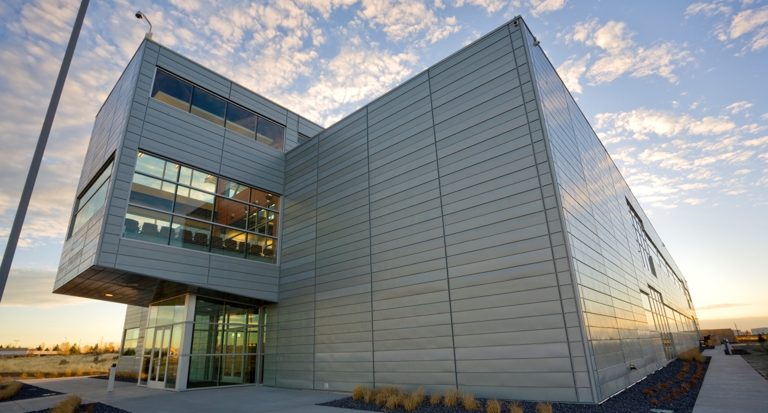
User Guide for Researchers

Contents
Abbreviations 1
Introduction 1
Process Outline 2
1 Propose a Project 2
2 Complete the work planning and safety envelope. 3
3 Conduct Research, Feedback, and Closeout 5
Roles and Responsibilities 7
CAES Contact Information 8
Documents 8

Abbreviations
AD | Associate Director
BSU | Boise State University
CAES | Center for Advanced Energy Studies
CSO | CAES Safety Officer
EB | Executive Board
ISU | Idaho State University
PPE | Personal protective equipment
RCA | Researcher Controlled Activity
RLM | CAES Research Laboratory Manager
SME | Subject Matter Expert
SOP | (Equipment) Standard Operating Procedure
UI | University of Idaho

Introduction
The Center for Advanced Energy Studies (CAES) offers exciting opportunities for collaborative research between Idaho National Laboratory (INL), Boise State University (BSU), Idaho State University (ISU), and the University of Idaho (UI). In order to facilitate the process, the CAES-046, Project Planning, Work Control, and Research Execution at CAES document describes how research is planned, controlled, and conducted at CAES.
Since there are several steps involved (including proposing projects, planning out the work, developing safety controls, executing research, providing feedback, and closing out projects), this guide is intended to help researchers complete all the required documentation and to provide resources to make it easier.
Each part of this guide correlates with the steps in the CAES-046, Project Planning, Work Control, and Research Execution at CAES document, and the colors and references help navigate to the corresponding sections. The forms needed for each step are also included. It is important to read the full instructions in the official documents – this guide is only a supplement.
In general, there are three main segments: 1) proposing the project, 2) creating the work plan, and 3) conducting the research. At any point in the process, the CAES Research Laboratory Manager (RLM) and the CAES Safety Officer (CSO) are excellent resources to assist with documentation, answer questions, and provide guidance.

Process Outline

Propose a Project

Read and agree to the CAES research guiding principles. [CAES-046, Step 0]

Initiate the process for requesting a research project at CAES.

Contact the CAES RLM. [CAES-046, Step 1]
This is an important step before proceeding with the proposal. The RLM can talk through the project idea and help evaluate the logistics and feasibility, which can save considerable time.

Complete the CAES-047, CAES Project Proposal form.
The purpose of the proposal is to detail the work that would be performed at CAES. It is very important to make sure the application is accurate. For instance, noting the true amount of space needed and all the potential hazards that might be encountered. If changes are made after the proposal is accepted, it is possible that accommodations will not be available, and the project would not be able to continue at CAES.

Address the following topics in the form.
Project description and how it aligns with the CAES mission
Student participation
Funding
Hazards and waste
Training needs
Operating procedures

Contact the associated institution’s export control authority.
This check needs to be documented and signed by an authorized export control representative before the proposal can be submitted.

(If applicable) Complete the CAES-006, Request to Install Equipment in CAES form.

If a new lab space needs to be created, work with the RLM to design and plan the construction.

Submit the CAES-047, CAES Project Proposal form to the RLM. [CAES-046, Step 1a]
The RLM will review for completeness and recommend any needed improvements before the proposal goes to the executive board (EB).

Contact the affiliated associate director (AD).
Although this is not an official requirement, it is a good idea to make sure the institution’s AD is aware of the project. The ADs can provide valuable insight, as well as champion the project.

Submit the CAES-047, CAES Project Proposal form to the EB for review. [CAES-046, Step 2]
The related institution’s AD will send a notification email with the EB’s decision. Once approved, the work plan (see step 2) must be submitted within 90 days. If it is not submitted, the proposal will be archived and removed from the approved active list, which means restarting the proposal process.

Complete the work planning and safety envelope.

Create a work plan using the CAES-048, CAES Work Plan form. [CAES-046, Step 4]

Work with the RLM to determine the appropriate level of work plan documentation.
Documentation ranges from a simple operating procedure, for low-risk activities, to detailed hazard mitigation plans, for high-risk activities. The RLM can help assess the degree of hazards.
Areas to address include:
  - Activity/task descriptions
  - Training requirements (in addition to the CAES general and lab specific training)
  - Risks and controls (e.g., engineering, administrative, and PPE), including off-normal condition hazards
  - Export compliance
  - Facility conditions
  - Emergency procedures
  - Post-performance activities
  - Supporting documentation
  - Drawings and diagrams
  - Chemical inventory
  - Waste generation and disposal
  - Home institution approvals (as needed)
  - Exit strategy (returning facility to original condition)

(Where applicable) Complete a CAES-002, Researcher Controlled Activity (RCA) form.
The RLM can help determine when this form is needed. Specifically, it applies to repetitive activities where all associated hazards are recognized and mitigated through the skills and/or physical techniques acquired by the researcher through training (general or specific), mentoring, or on the job training over time for a specific discipline or activity. These skills are typical of an individual hired to meet the requirements listed in a company position description. Skills, training, and experience, enable the researcher to recognize and mitigate ordinary hazards common to the activities the person customarily performs. One-time activities would generally go in the CAES-048, CAES Work Plan, rather than in the CAES-002, Researcher Controlled Activity form.

Complete (or reference) the CAES -034, Equipment Standard Operating Procedure (SOP) form for each device that will be used.
This level of documentation is determined by the type, complexity, hazards of operation, and nature of application. The SOP template should be used unless otherwise negotiated with the CSO. It is a good idea to check with the RLM or CSO to see if existing procedures for similar equipment already exist, which could be modified or amended.

Complete CAES trainings.
The training must be completed for all researchers, including students, who will be working on the project.
The required trainings for the first three levels and unescorted laboratory access are implemented through the CAES Training System, Litmos. CAES-specific protocols are superseded by and need to align with any and all existing safety standards of the CAES building facilitator, Idaho State University (ISU). The minimum required trainings include:
  - Facility
  - Core Laboratory
  - Laboratory-Specific
  - Project-Specific

Document training and skills/knowledge/experience. [CAES-046, Step 5]
This step will reoccur every time someone new is trained or whenever new information is gained during the research experience that would impact the way actions are completed.
In the case of routine, low-risk, researcher-controlled work, documentation is needed to show that the performer has the proper knowledge, skills, experience, and/or training to perform the work safely using the CAES-002, Researcher Controlled Activity template.
In more complex cases, which may entail more risk, researchers are required to document work activity hazards, mitigations, and controls in the CAES-048, CAES Work Plan.

Submit required forms to the CSO.
  - CAES-048, CAES Work Plan
  - (Where applicable) CAES-002, Researcher Controlled Activity
  - CAES -034, Equipment Standard Operating Procedure
A project review team, which includes the CSO and RLM, will review the work plan package to ensure completeness.

Set up the laboratory space.
The lab space can be put in place while the work plan is being completed. Equipment can be tested, and limited training can begin. However, no research can be started until the Readiness Review (see step 2.5) has been finalized.

Participate in the focused review meeting. [CAES-046, Step 5]
After the CAES-047, CAES Project Proposal and CAES-048, CAES Work Plan are submitted and reviewed by the CSO or RLM, the project will be presented for consideration by the CAES Safety Committee during a focused review.
The committee composition will be based on the type of project and hazards associated with the proposed scope of work. The safety committee will address concerns related to space, safety, and facility infrastructure to determine if CAES can support the project and to provide feedback on the details needed to plan and execute the proposed project workscope. For complex projects, the safety committee may request input from subject matter experts (SME) as well as a presentation from the researchers. It is within the roles and responsibilities of the CAES Safety Committee to deny access due to limited resources.
For short-term low-risk activities, the CAES RLM and CSO may approve the space assignment without additional review by the CAES Safety Committee. All short-term low-risk activities that overrun a six-month window must submit a full application for review by the EB and CAES Safety Committee.

Prepare for the Readiness Review. [CAES-046, Step 6]

Review the CAES-003, CAES Readiness Verification Checklist to look for areas that need to be completed.

Ensure all equipment is installed and apparatuses are assembled.

Make sure all documentation is completed and up-to-date, including the CAES-048, CAES Work Plan, training records, and all CAES-002, Researcher Controlled Activity procedures and CAES -034, Equipment Standard Operating Procedure.

Complete Readiness Review. [CAES-046, Step 6a]
Approval to start work is granted by the CSO only after the Readiness Review is completed. The researchers and the project review team will complete activities needed to finalize project readiness (e.g., final walk down), personnel (e.g., training) and equipment (e.g., installation and passive testing). Any pre-start issues identified will need to be resolved before starting work.
The CSO, RLM, and laboratory lead perform the Readiness Review per CAES-003, CAES Readiness Verification Checklist. The content of the review, level of rigor, and participants will be tailored to the project. The review consists of an informal presentation of experimentation to selected CAES Safety Committee members: at a minimum the lab lead, designated SMEs, CSO, and RLM.
NOTE: More than one readiness review may be required prior to approval.

Conduct Research, Feedback, and Closeout

Update the laboratory manual as needed and whenever there are changes. [CAES-046, Step 7]
A laboratory manual is maintained in each laboratory or other research space, which includes a current copy of the CAES-048, CAES Work Plan.

Manage the configuration of project documentation, in consultation with the CSO. [CAES-046, Step 7]

Communicate project information by participating in building and seminar series, information exchanges, meet and greets, and other community-building and collaboration-promoting activities. [CAES-046, Step 7]

Conduct Research. [CAES-046, Step 8]

Complete the move into CAES and begin working within 60 days of the readiness review approval.

Submit a space self-evaluation, annually through project completion, to be evaluated by the CAES EB and CAES Safety Committee.

Submit any changes to the project scope to the CAES Safety Committee for review.

Perform routine inspections. [CAES-046, Step 9]
The researchers and CSO are responsible for performing routine inspections to confirm that the work environment and equipment continue to function as planned and to support productive and safe work. Individual contributors are encouraged to lead or participate in these inspections, which are conducted using the CAES-007, CAES Laboratory Safety Inspection Checklist. The inspections can be used as a teaching tool for students.

Obtain and review the CAES-007, CAES Laboratory Safety Inspection Checklist.

Perform the inspections with the CSO.

Communicate relevant inspection results to the CAES community for lessons learned.

Update the CAES-048, CAES Work Plan regarding potential scope change(s). [CAES-046, Step 10]

Engage the CSO to assess if a possible change in scope warrants a subsequent change in the project documentation, including hazard identification and mitigation.

Engage the CAES RLM and CSO to develop and approve updates to the work plan due to any changes in scope.

Obtain additional home institution safety committee and CAES Safety Committee reviews, as needed, depending on the magnitude of the change.

Comply with any home institution work plan-review processes.

Determine if lessons learned during project execution warrant any improvements in how the work is performed and if the changes need to be communicated to others in the CAES community.

Participate in the Safety Committee Oversight. [CAES-046, Step 11]
The CAES Safety Committee will meet regularly and provide a forum for crosscutting safety-related issues. The responsibilities of this committee include making decisions on changes to CAES Environment, Safety and Health and operations processes, sharing and distributing lessons learned, and providing a forum for CAES occupants to communicate ideas and concerns.

Review the Work Plan at least annually. [CAES-046, Step 12]
The RLM can help determine whether current work scope adheres to existing work control documentation, including operating procedures, hazard identification, and the safety envelope boundaries.

Project Extension/Completion. [CAES-046, Step 13]

Complete the project.
Space within CAES is allocated on a project-by-project basis. Upon project completion:

Notify the CSO and RLM of project completion.

Identify the disposition of equipment installed.

Notify the RLM if additional research may benefit from the equipment remaining within CAES past the project’s completion.

Vacate and return the assigned space to useable condition within 10 business days of the end of project.

Meet with CSO to schedule and dispose of hazardous and radiological wastes.

(If needed) Apply for an extension.

Examine the risk envelope (hazards/mitigations) to assure nothing has changed or been added.

Evaluate lessons learned for potential improvements to processes (safety, efficiency, effectiveness, etc.).

Inform the CAES Safety Committee of intentions to apply for extension. This can be accomplished through a written notification (email, etc.) to the CSO.

Request an extension of time from the CAES Safety Committee, with assistance from the RLM, CSO, or other members of the safety committee as needed. A new work plan is not necessary.

Responsibilities
Note: These may not all be accurate at this time: gleaned from an outdated reference. List is likely not complete.
Executive Board (EB)
- Reviews and approves the work at CAES for mission alignment and overarching facility envelope
Laboratory Lead
- Prepares plans to develop, construct, and prepare the lab using established procedures and business protocols
- Oversees the research execution, feedback, and closeout
Researcher
- Plans work in accordance with existing home institution policies, procedures, and requirements, while at the same time meeting any additional CAES requirements
- Works with the RLM and the CSO to prepare documentation with an appropriate outline of the project and an overview of the hazards involved
- Oversees the research execution, feedback, and closeout
Research Laboratory Manager (RLM)
- Prepares plans to develop, construct, and prepare the lab (non-project specific) using established procedures and business protocols
- Works with the researchers and the CSO to prepare documentation with an appropriate outline of the project and an overview of the hazards involved
- Oversees the research execution, feedback, and closeout
Safety Committee (RLM, CSO, LL, and appropriate Subject Matter Experts)
- Approves the work control and safety envelope for the project and its location within CAES
- Makes decisions on changes to CAES Environment, Safety and Health and operations processes; shares and distributes lessons learned; and provides a forum for CAES occupants to communicate ideas and concerns
Safety Officer (CSO)
- Works with the researchers and the RLM to prepare documentation with an appropriate outline of the project and an overview of the hazards involved
- Prepare plans to develop, construct, and prepare the lab using established procedures and business protocols
- Oversees the research execution, feedback, and closeout

CAES Contact Information
Role | Name | Email | Phone
Director | Terry Brog | Terrence.Brog@inl.gov | 208.526.3984
Executive Assistant | Donna Wuthrich | Donna.Wuthrich@inl.gov | 208.526.1784
Research Laboratory Manager | Rockland McDowell | Rockland.McDowell@inl.gov | 208.526-3198
Safety Officer | Kristi D. Moser-McIntire | mosekri3@isu.edu | 208.533-8133
BSU Associate Director | Dave Estrada | daveestrada@boisestate.edu | 208.426.6132
ISU Associate Director | Dave Rodgers | davidrodgers@isu.edu | 208.282.3365
UI Associate Director | John Russell | jtrussell@uidaho.edu | 208.533.8164

Executive Board | Name | Institution
Director | Terry Brog | Idaho National Laboratory
BSU Associate Director | Dave Estrada | Boise State University
ISU Associate Director | Dave Rodgers | Idaho State University
UI Associate Director | John Russell | University of Idaho

Documents
CAES-002, Researcher Controlled Activity
CAES-003, CAES Readiness Verification Checklist
CAES-006, Request to Install Equipment in CAES
CAES-007, CAES Laboratory Safety Inspection Checklist
CAES -034, Equipment Standard Operating Procedure
CAES-046, Project Planning, Work Control, and Research Execution at CAES
CAES-047, CAES Project Proposal
CAES-048, CAES Work Plan
CAES-052, Laboratory Lead Selection Process

