How to submit an IRB closure form in VERAS

- Use the My Workspaces Menu to choose Study Assistant, then click on View My Studies to view all of your IRB protocols.
- Scroll down to IRB Studies.
- To the right of the study, select “Forms”, which has an icon that looks like a clipboard.

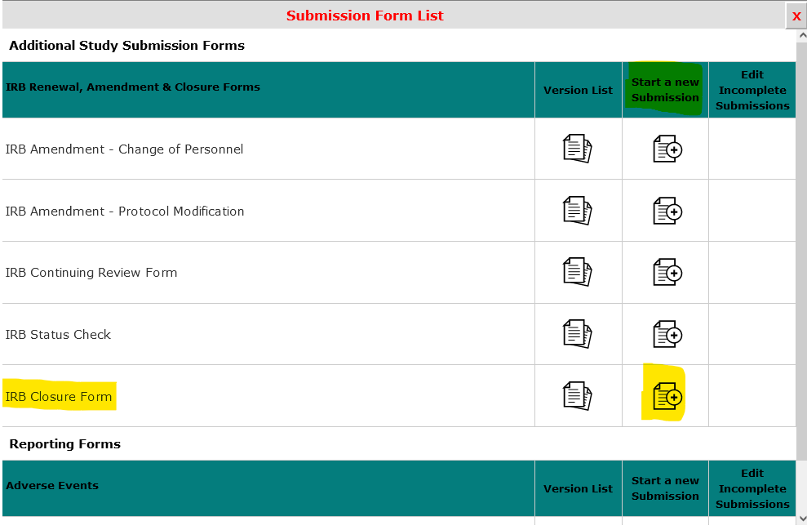
- Answer the questions in the form.
- When finished, select “Save and Continue in the Next Section” in the upper right-hand corner.
- If you are the PI, you will be able to select “Signoff and Submit”. If you are not the PI, please notify the PI that the form is ready for electronic signature and select “Exit Form”.
- If you are the PI, complete the final approval, and then select “Save Signoff”.

