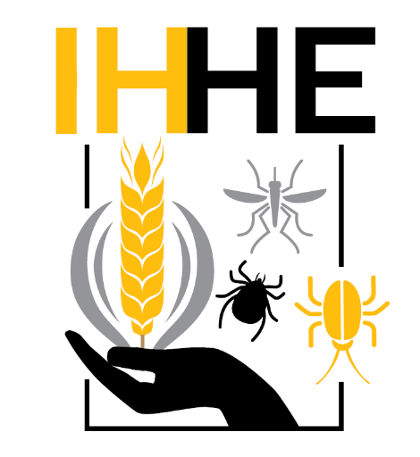
IHHE Research and Extension Experiences for Undergraduates (REEU) Traineeship Application

Applications for IHHE REEU Traineeship awards will be accepted until the deadline of 5 p.m. on Dec. 15. Late applications will not be accepted. Awardees will be notified before the beginning of spring semester.
Eligibility: UI undergraduate students must be enrolled full time in any major. Qualified students must have completed coursework for the first year of their majors, with a minimum of 16 credit hours of STEM-based courses. Applicants must be working with a faculty or industry mentor to develop and submit a research proposal focused on plant, animal or human health in complex, managed ecosystems.
Award and Conditions: Successful applicants will receive a traineeship award of $7,000 (stipend + research support) for a summer research traineeship. As a condition of accepting the award, awardees are expected to present their work during the annual IHHE Research Symposium which is held every spring semester. Additionally, in the second year of their traineeship, awardees will gain training as peer mentors to guide the next cohort of first year REEU students in the preparation of their research proposals and through sections of their research experience.
Student Name (Last, First, Middle):
U of Idaho Vandal ID#: Email:
GPA: Current academic standing:
Anticipated Graduation Date: Major:
Name of Faculty or Industry mentor (PI):

Please provide the information below.
- The title of your research project.
- A brief description of your research project (2-3 sentences).
- Describe why you are interested in doing this research (2-3 sentences).

PLEASE INCLUDE THE FOLLOWING INFORMATION WITH YOUR APPLICATION:
- Project description
  - Maximum three single spaced pages of text, minimum margin size of 1”, 12 point font in Arial, Times New Roman, or Calibri.

  - Include the following sections:
    - A brief but descriptive Title reflecting the goals of the proposed work
    - Research Question, Background and Research Objectives
    - Explicit statement of specific Hypothesis/Hypotheses to be tested
    - Experimental Protocols and Timeline of Activities
    - Anticipated Results and Potential Pitfalls
    - Literature Cited (any standard format may be used for Literature Cited, as long as this format is consistently followed throughout the proposal)

  - Please explicitly address how your project fits within the scope of factors affecting “plant, animal or human health and diseases.”

- Transcript (an unofficial copy will suffice)

- Letter of support from your faculty or industry mentor. Letter should address the following:
  - How long the mentor has known the student.
  - The student’s qualifications.
  - How the student’s project relates to ongoing research of the mentor’s lab/operation.
  - Whether the project is feasible in the above-mentioned timeframe.
  - The mentoring support you anticipate being able to offer the student during the project.

Email your application to Glen Stevens (glens@uidaho.edu), REEU Primary Mentor.

