How a PI can sign off on a student submitted protocol:

Go into the main VERAS screen and choose “My Workspaces” and then “Study Assistant”.

From there, under “Study Tasks”, choose “Study Tasks”, as below. This will allow the PI to select the correct study by checking the pencil and paper icon under “Click to open”.

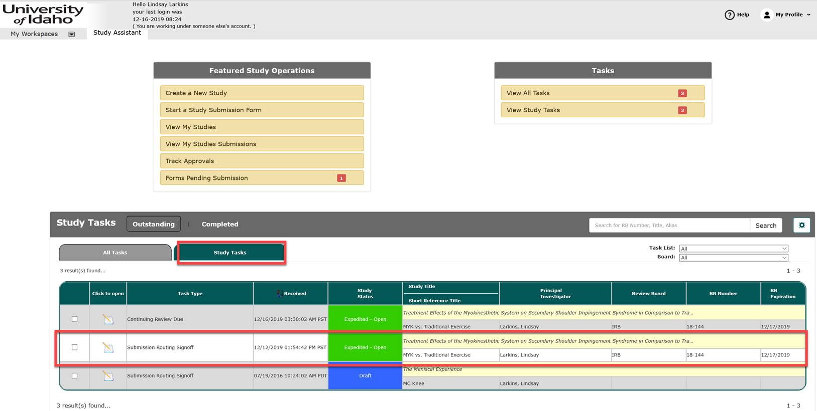

This should bring the PI to the final sign off screen, as seen below. The PI then needs to review the documents and then choose “Approve” or “Deny” and then “Save Signoff”. If the PI approves the protocol it will route to the IRB. If the PI denies the protocol it will route back to the person who sent it to the PI. The PI may choose to add comments to advise that person what needs to be changed prior to sign off.

