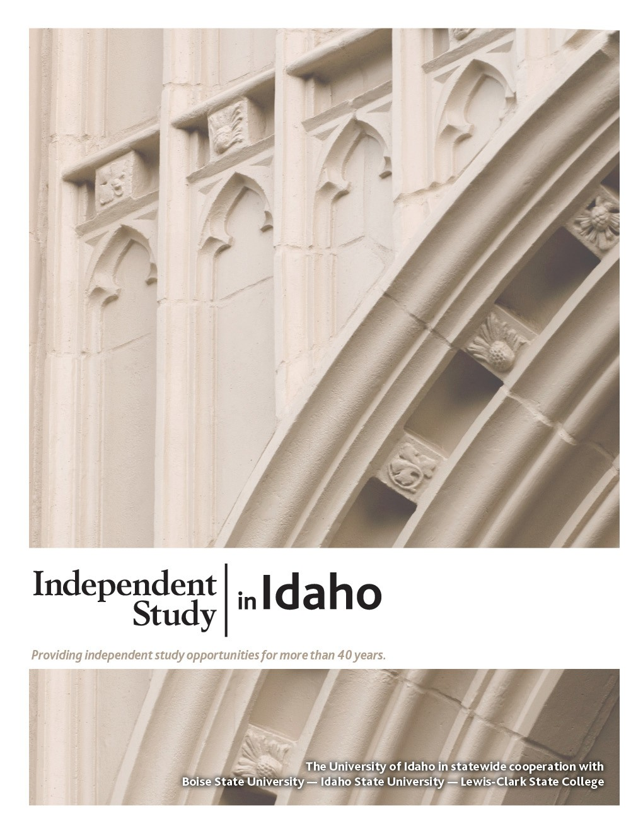
GEOL 102
Historical Geology

Course Guide

Self-paced study. Anytime. Anywhere!

Geology 102
Historical Geology

University of Idaho
3 Semester-Hour Credits

Prepared by:
Renee Love, Ph.D.
University of Idaho

WR: February 2021
1 – GEOL 102
Copyright Independent Study in Idaho/Idaho State Board of Education

Table of Contents
Welcome! 1
Policies and Procedures 1
Course Description 1
Course Materials 1
Course Delivery 1
Course Introduction 1
Course Objectives 3
Lessons 3
Exams 5
Grading 5
About the Course Developer 5
Contacting Your Instructor 6
Geologic Time Scale 7

Lesson 1: Earth as a System and Plate Tectonics 9
Lesson 2: Rocks and Minerals, Environments of Deposition, and Stratigraphy 11
Lesson 3: Dating Principles and Early Earth 13
Midterm Study Guide 17

Midterm Exam Information: Covers Lessons 1–3 19

Lesson 4: The Fossil Record and Paleozoic History 20
Lesson 5: Late Paleozoic and Mesozoic History 22
Virtual Field Trip of the K-T Boundary 24
Lesson 6: Late Cenozoic and the Holocene 31
Final Study Guide 33

Final Exam Information: Covers Lessons 4–6 35

GEOLOGY 102 Historical Geology 3 Semester-Hour Credits: U of I

Welcome!
Whether you are a new or returning student, welcome to the Independent Study in Idaho (ISI) program. Below, you will find information pertinent to your course including the course description, course materials, course objectives, as well as information about assignments, exams, and grading. If you have any questions or concerns, please contact the ISI office for clarification before beginning your course.

Policies and Procedures
Refer to the ISI website at www.uidaho.edu/isi and select Students for the most current policies and procedures, including information on setting up accounts, student confidentiality, exams, proctors, transcripts, course exchanges, refunds, academic integrity, library resources, and disability support and other services.

Course Description
Evolution of the physical earth, plants, and animals; techniques used in the interpretation of geologic history. Corequisite: GEOL 102 Lab. U of I students: Gen Ed: Natural and Applied Sciences

1 graded assignment, 6 quizzes, 2 exams
Available online only.

Students may submit up to 2 assignments per week. Before taking exams, students MUST wait for grades and feedback on assignments, which may take up to three weeks after the date of receipt by the instructor.

ALL assignments and exams must be submitted to receive a final grade for the course.

The Geol 102 Lab is not a required part of this class, but it is highly recommended that you take it with the lecture. Sign up for the Geol 102L if you haven't already. It will reinforce some of the major concepts that you will be expected to learn in the class.

Course Materials
Required Course Materials
Stanley, Steven M. and John A. Luczaj. Earth System History, fourth edition, 2015. ISBN-10: 1-4292-5526-9; ISBN-13: 978-1-4292-5526-4.

Author Steven Stanley is at the University of Hawaii at Manoa, and John Luczaj is from the University of Wisconsin-Green Bay.

Course Delivery
All ISI courses are delivered through Canvas, an online management system that hosts the course lessons and assignments and other items that are essential to the course. Upon registration, the student will receive a Registration Confirmation Email with information on how to access ISI courses online.

Course Introduction

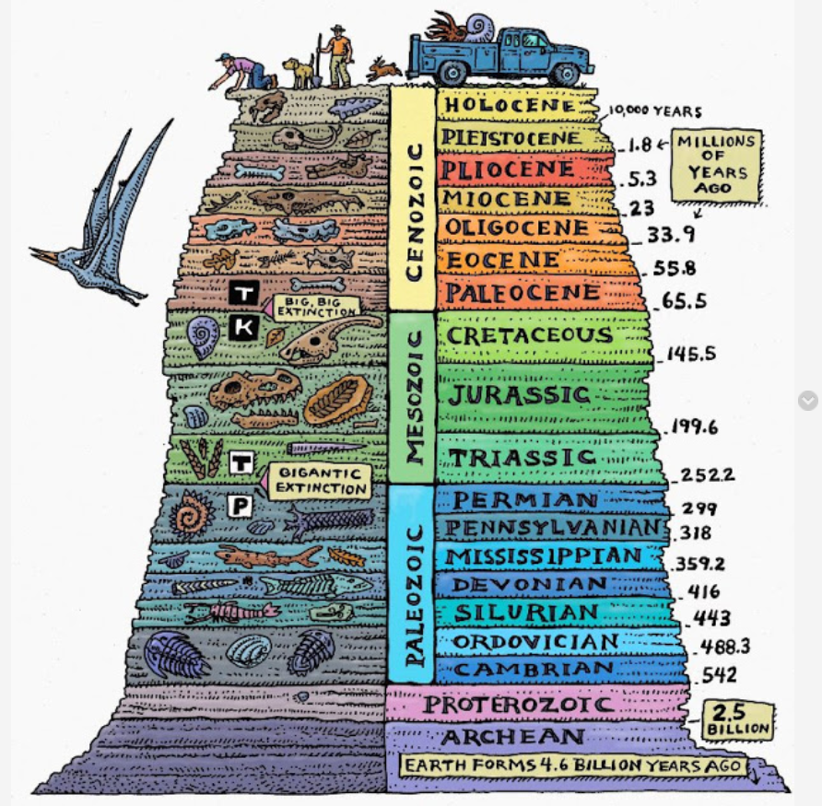

Time Scale by Ray Troll

Welcome to Historical Geology!

"The world is the geologist's great puzzle-box; stand before it like the child to whom the separate pieces of their puzzle remain a mystery till you detect their relation and see where they fit, and then their fragments grow at once into a connected picture beneath your hand." -- Louis Agassiz

On a human timescale, we see the earth as mostly unchanging. However, looking at the earth with a geologic lens, we see a dynamic planet that is ever-changing in dramatic ways. The one norm for the earth is that it has always been in constant flux and change. Like the quote above, geologists put together puzzle pieces of the past to decipher these dramatic changes through earth history. Sometimes puzzle pieces are missing, but those pieces will eventually be discovered to give a more complete story of the puzzle.

The earth is about 4.6 billion years old. That is 4,600,000,000 years old! Generally, humans think in a hundred year to several hundred-year times-scales, not billions of years. It is hard to grasp how long that is on a human timescale. Geologists use the principle of uniformitarianism, meaning that the present is key to the past, to determine past earth conditions during its long history.

Throughout geologic history, mountains have been built and then eroded into rivers, flowing to the sea. Continents have moved and collided with one another, then moved apart. Rivers have cut giant canyons, and glaciers spanning whole continents have formed and melted again. The earth around us can look unchanging because, from the human perspective, most geologic change is slow. This course will introduce you to what is called deep time and give you a feeling for the forces which are constantly, if slowly, reshaping the earth around us. Geology is an applied science, and you can see examples of what you will be reading about in the world around your home and town.

If you complete this course successfully, the rest of your life will be different. The rocks you see along the roadside will have new meaning to you. If you visit a national park, you will see much more than the scenery. You will be able to understand how mountains form. You may be able to say something about the rocks or what part they have played in the geologic history of North America.

To describe the earth and the forces which change it, geologists have developed a specialized vocabulary. Each lesson will focus on a different topic important to evaluating earth through time. You are expected to read the corresponding chapters in your book (Earth System History by Steven M Stanley and John A Luczaj) to be prepared for labs, quizzes, and exams. Please contact me regularly with any and all questions by email.

Course Objectives
What you will learn in this class is the history of the earth.

- How the earth was formed and what early earth was like
- How mountains and some valleys are connected to catastrophic events like earthquakes and volcanic eruptions
- How continents were in different places on the planet than what we see today
- How to interpret geologic—including evolutionary and climatic—information from the rock and the fossil record
- How geologists date rocks and events in the history of the earth
- What evolution is and what the evidence for evolution is in the fossil record

Lessons
Overview
Read through the syllabus and course schedule on Canvas to know what is expected of you to complete this course. If you have any questions, please don't hesitate to contact me

The lessons will give you a to-do list for each module (reading, labs, lectures, and quizzes). Make sure to view these first before going to the lab assignments, discussions, or trying to complete a quiz/exam.

There are 6 lessons in this course. Each lesson contains assigned chapters to read, lecture presentations to review, lab assignments, and quizzes. To prepare for the midterm and final, review each of these items in each lesson.

Each lesson may include the following components:
- reading assignment
- lecture
- quiz
- lab, for those enrolled in GEOL 102L

GEOL 102 Lab Assignments (for students concurrently enrolled in the lab course)
Each lab assignment follows each lesson and can be submitted through the 'Lab Assignments' link under your Geol 102L class. These labs will help you understand the main concepts in this course that are presented in lecture and the book.

Study Hints:
- Keep a copy of every assignment submitted.
- Complete all reading assignments.
- Set a schedule allowing for course completion one month before your personal deadline. An Assignment Submission Log is provided for this purpose.
- Web pages and URL links in the World Wide Web are continuously changing. Contact your instructor if you find a broken Web page or URL.

Refer to the Course Rules in Canvas for further details on assignment requirements and submission.

Lesson | Reading | Assignments/Labs (if enrolled in GEOL 102L) | Quiz
1 | Ch.1: Earth as a System, Ch.8: The Theory of Plate Tectonics | Familiarize yourself with the syllabus and requirements in this class; order the textbook
1 | Ch.9: Continental Tectonics and Mountain Chains | Lab 1: Geologic Time Scale | 1
2 | Ch.2: Rock-forming Minerals and Rocks | Lab 2: Plate Tectonics and Paleogeography
2 | Ch.4: Environments and Life, Ch.5: Sedimentary Environments | Lab 3: Minerals and Rocks | 2
3 | Ch.6: Correlation and Dating of the Rock Record | Lab 4: Relative Dating and Biostratigraphy
3 | Ch.11: The Hadean and Archean Eons | Lab 5: Recambrian of Idaho and Absolute Dating
3 | Ch.12: Proterozoic | Lab 6: PC and Paleozoic Life Geohistory | 3
Deadline #1 Before taking the midterm exam, everything from Lessons 1—3 must be submitted.
Midterm Exam

Lesson | Reading | Assignments/Labs (if enrolled in GEOL 102L) | Quiz
4 | Ch.3: Diversity of Life, Ch.7: Evolution and the Fossil Record | Lab 7: Fossils
4 | Ch.13: Early Paleozoic, Ch.14: Middle Paleozoic | Lab 8: Sea Level Changes through Time and Paleogeography | 4
5 | Ch.15: Late Paleozoic | Lab 9: Mesozoic History
5 | Ch.16: Early Mesozoic, Ch.17: Cretaceous | Lab 10: Climate Change using Fossil Plants | 5
6 | Ch.18: The Paleogene World | Lab 11: Cenozoic History
6 | Ch.19: Late Cenozoic, Ch.20: Glaciers and the Holocene | Lab 12: Geologic History of Idaho | 6
Finish everything up! |  | Assignment 2: Virtual Field Trip
Deadline #2 Before taking the midterm exam, everything from Lessons 4—6 must be submitted.
Final Exam

Exams
- You must wait for grades and comments on assignments before taking subsequent exams.
- For your instructor's exam guidelines, refer to the Course Rules in Canvas.

Refer to Grading for specific information on assignment/exam points and percentages.
Grading
The course grade will be based upon the following considerations:

Assignment Points Percentage  Quizzes (6 @ 20) 120 30  Midterm & Final (2 @ 100 200 50  Virtual Field Trip 80 20  Total 400 100 | A = 90% to 100%  B = 80% to 89%  C = 70% to 79%  D = 60% to 69%  F = 59% or less
Quizzes
Quizzes will be open-note and open-book. Each quiz contains 20 multiple choice questions. Before taking any quiz in this course you should thoroughly read all assigned chapters in your textbook, and review all PowerPoint lectures for that lesson. Some students also find it helpful to complete the practice questions and review the important terms at the end of each chapter. The practice questions in your text are meant to quickly test your understanding and to locate any gaps in your understanding. The lectures are also posted to help you focus on the important concepts in each chapter. Use these quizzes to study for the midterm and final.

Midterm and Final
There will be a midterm and final in this course. There are Midterm and Final Study Guides on Canvas.The midterm will cover chapters 1-12 (except chapter 10) and the final will cover chapters 13-20. Quizzes and lab assignments are meant to help you prepare for these exams. There will be 50 multiple choice questions on each exam. You will have two hours total to complete each exam.

Technology Issues
Although every effort is made to ensure a smoothly running course space, there may be times when you are asked to resubmit an assignment or retake a quiz due to a computer error.

The final course grade is issued after all assignments and exams have been graded.

Acts of academic dishonesty, including cheating or plagiarism, are considered a very serious transgression and may result in a grade of F for the course.

About the Course Developer
I graduated with my BS degree from Washington State University in geology and earned my Ph.D. from the University of Idaho in geology/paleobotany/stratigraphy. I worked for ExxonMobil for several years in Houston, TX, and then was a geoscientist at the Idaho Geological Survey for a couple more years. Now I am faculty at the University of Idaho. When I took this class as an undergraduate, this was my favorite geology class. Now it is my favorite class to teach. I hope you enjoy the content as well. It integrates plate tectonics, the fossil record, climate, and major global events through geologic time.
Renee Love

Contacting Your Instructor
Instructor contact information is posted on your Canvas site under Course Rules.

GEOLOGIC TIME SCALE Name__________________________________

Print clearly the names of the geologic eons, eras, periods and epochs in the spaces provided. Write the absolute ages of the era boundaries in the double-line boxes.
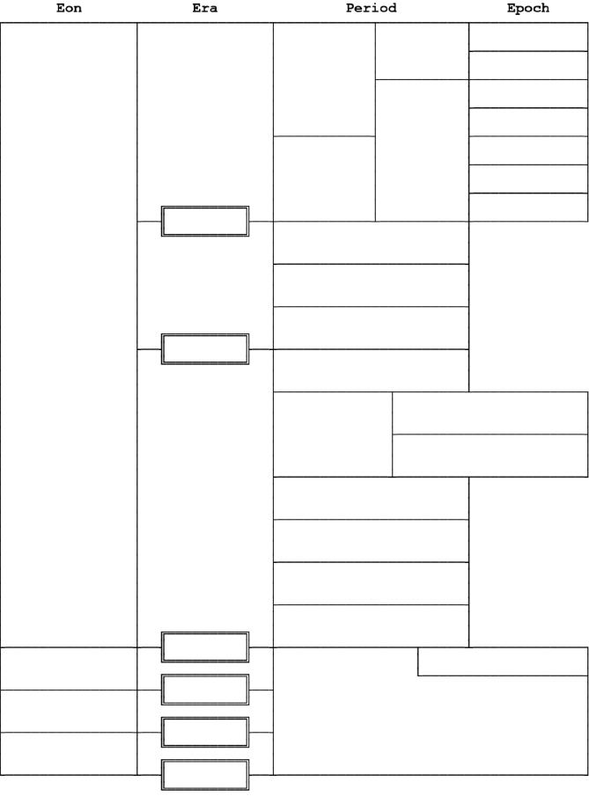
GEOLOGIC TIME SCALE Name__________________________________
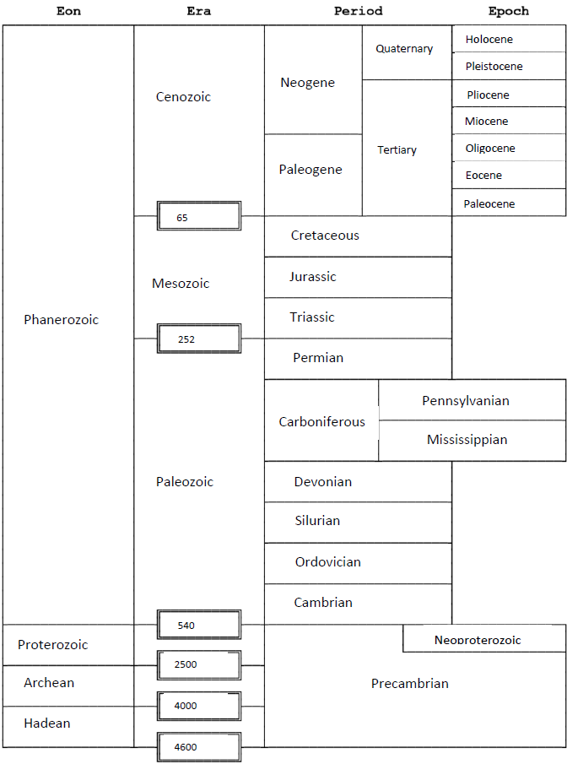
Lesson 1
Earth as a System and Plate Tectonics

Lesson Objectives
When you have completed this lesson, you should be able to do/understand the following:

- Discuss the origin of and earth's place in the solar system.
- Recognize and apply all the eons, eras and periods of the geologic time scale.
- Discuss the evolution of the Plate Tectonic Theory and the different plate boundary types, processes, features, and hazards associated with each boundary type.
- Describe mountain building and continental rifting
- Understand the origin of the Solar System and how Earth formed

Reading Assignment
Read chapters 1, 8, 9

Introductory Lecture and To Do List
Plate tectonics has played a large role in the isolation and evolution of different species through geologic time. The result of mountain building (i.e. uplift) is related to the depositional hiatuses (or unconformities) that you learned in the previous lessons. In this scenario, depositional basins can be small and isolated and will be surrounded by areas of erosion and/or nondeposition. Conversely, the divergence of tectonic plates can create deep depositional basins. Fossils can be preserved in areas of deposition within these basins. Convergence of oceanic to continental plates can also create a deep oceanic basin.

Historical Geology examines the origin and evolution of Earth. But, Historical Geology is more than just a list of past events. The earth is a dynamic planet, which means it has changed over the past 4.6 billion years of history. It is important to start this course by examining the earth's materials and processes. Studying minerals, rocks, fossils and processes such as plate tectonics will help you to understand how and why the earth has changed over time.

Recorded Lectures
Lectures (these help you understand the key important points in each chapter-- I recommend looking at them after you've read the chapter for a review)
- Lecture1_TimeRLL_Recorded.pdf
- Lecture1_TimeRLL_Recorded.ppsx
- Lecture2_PlateTectonicsRLL_recorded.pdf
- Lecture2_PlateTectonicsRLL_recorded.ppsx

Videos to watch:
Geologic Time
- The formation of the solar system by Stephen Hawking: https://www.youtube.com/watch?v=Uhy1fucSRQI
- Where did the moon come from (BBC): https://www.youtube.com/watch?v=c0FCE4H0Dro
- Earth's entire history (visualized on a football field): https://www.youtube.com/watch?v=M8V_glRW1hA&feature=emb_logo

Plate Tectonics
- Sea floor spreading and plate tectonic evidence: https://www.youtube.com/watch?v=ZzvDlP6xd9o
- Convection: https://www.youtube.com/watch?v=ryrXAGY1dmE
- Plate Tectonics (Mike Sammartano), watch this in segments as described in the lecture: https://www.youtube.com/watch?v=ZTRu620bIsE&t=2s
- Plate Tectonics, 540 Ma-modern world, Scotese Animation: https://www.youtube.com/watch?v=g_iEWvtKcuQ
- Future plate motions and Pangeo proxima - Scotese animation: https://www.youtube.com/watch?v=2It3ETk2MGA

Other resources that might help you:
- Brief history of geologic time: https://www.youtube.com/watch?v=rWp5ZpJAIAE&t=292s
- Continental Drift: https://www.youtube.com/watch?v=_5q8hzF9VVE
- USGS link that will help you determine plate boundaries: https://pubs.usgs.gov/gip/dynamic/understanding.html

GEOL 102 (for students concurrently enrolled in the lab course).
- Lab 1: Geologic Time Scale

Written Assignment
Take Quiz 1 on Canvas. 20 points possible

