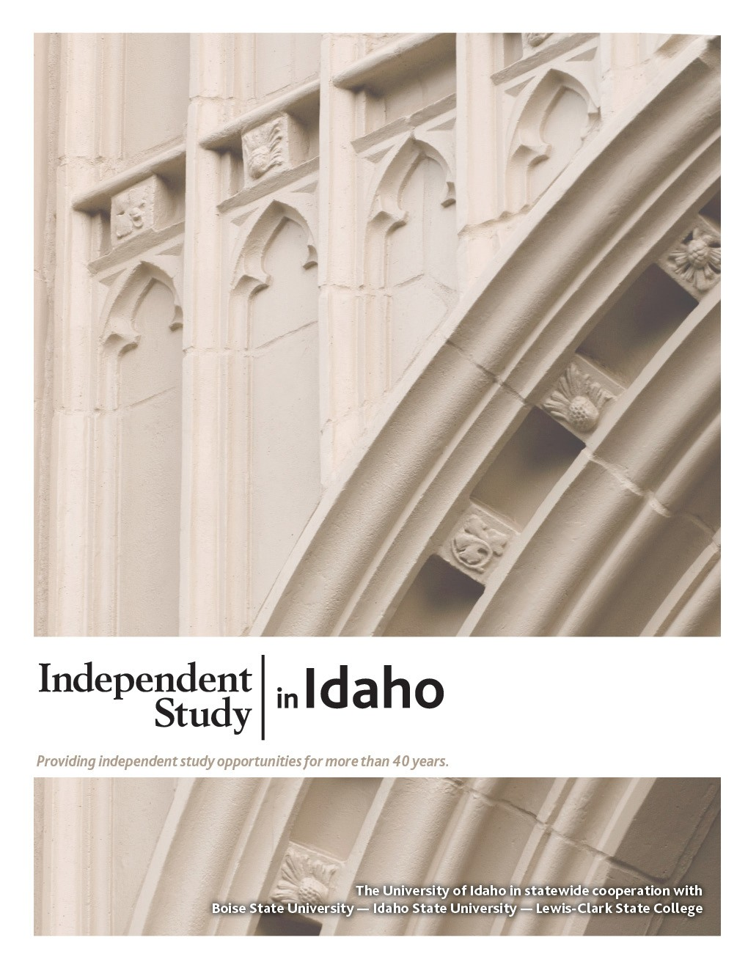
GEOL 102L
Historical Geology Lab

Course Guide

Self-paced study. Anytime. Anywhere!

Geology 102L
Historical Geology Lab

University of Idaho
3 Semester-Hour Credits

Prepared by:
Renee Love, Ph.D.
University of Idaho

WR: February 2021
1 – GEOL 102
Copyright Independent Study in Idaho/Idaho State Board of Education

Table of Contents
Welcome! 1
Policies and Procedures 1
Course Description 1
Course Materials 1
Course Delivery 1
Course Objectives 1
Course Introduction 2
Lab Lessons 3
Grading 3
Technology 4
About the Course Developer 4
Contacting Your Instructor 4

Lab 1: Geologic Time Scale 5
Geologic Time Scale Form 6
Lab 2: Plate Tectonics and Paleogeography 9
Lab 3: Minerals and Rocks 10
Lab 4: Relative Dating and Biostratigraphy 12
Lab 5: Precambrian of Idaho and Absolute Dating 13
Lab 6: Precambrian and Paleozoic Life - Walking with Monsters Geohistory 14
Lab 7: Precambrian and Paleozoic Life - Fossils 16
Lab 8: Sea Level Changes and Paleogeography 17
Lab 9: Mesozoic History 19
Lab 10: Climate Change Using Fossil Plants 20
Lab 11: Cenozoic History 22
Lab 12: Geologic History of Idaho 23

GEOLOGY 102L Historical Geology Lab 1 Semester-Hour Credits: U of I

Welcome!
Whether you are a new or returning student, welcome to the Independent Study in Idaho (ISI) program. Below, you will find information pertinent to your course including the course description, course materials, course objectives, as well as information about assignments, exams, and grading. If you have any questions or concerns, please contact the ISI office for clarification before beginning your course.

Policies and Procedures
Refer to the ISI website at www.uidaho.edu/isi and select Students for the most current policies and procedures, including information on setting up accounts, student confidentiality, exams, proctors, transcripts, course exchanges, refunds, academic integrity, library resources, and disability support and other services.

Course Description
Evolution of the physical earth, plants, and animals; techniques used in the interpretation of geologic history. Corequisite: GEOL 102. U of I students: Gen Ed: Natural and Applied Sciences

12 graded assignments and 0 exams
Available online only.

Students may submit up to 2 assignments per week. Grading may take up to three weeks after the date of receipt by the instructor.

ALL assignments and exams must be submitted to receive a final grade for the course.

The Geol 102 lecture course (3-credits) is not required for this course, but it is highly recommended that you take it along with the lab course. It will reinforce the major concepts that you will be expected to learn in the class. Sign up for the Geol 102, if you haven't already!

Course Materials
There are no quizzes or exams or textbook for this course.

Course Delivery
All ISI courses are delivered through Canvas, an online management system that hosts the course lessons and assignments and other essential items. Upon registration, the student will receive a Registration Confirmation Email with information on how to access ISI courses online.

Course Objectives
What you will learn in this class is the history of the earth.
- How the earth was formed and what early earth was like
- How mountains and some valleys are connected to catastrophic events like earthquakes and volcanic eruptions
- How continents were in different places on the planet than what we see today
- How to interpret geologic—including evolutionary and climatic—information from the rock and the fossil record
- How geologists date rocks and events in the history of the earth
- What evolution is and what the evidence for evolution is in the fossil record
Course Introduction

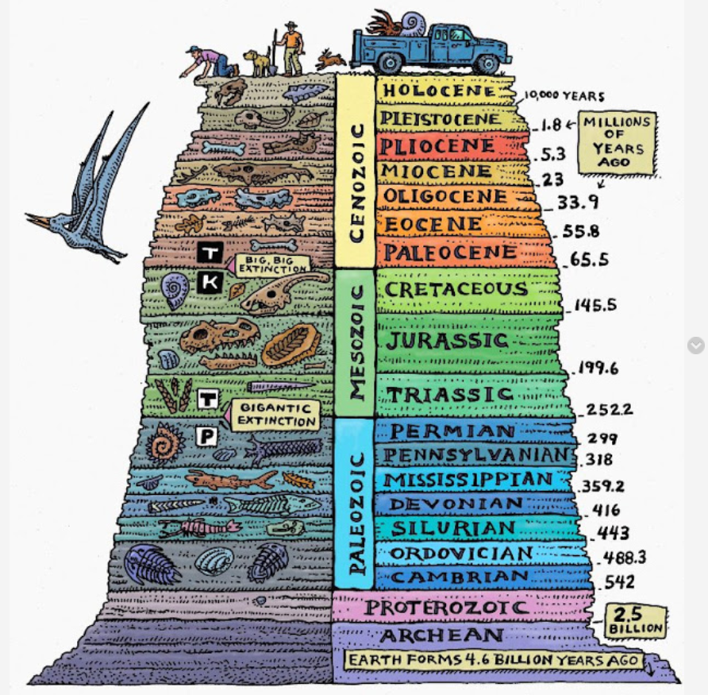

Time Scale by Ray Troll

Welcome to Historical Geology!

“The world is the geologist’s great puzzle-box; stand before it like the child to whom the separate pieces of their puzzle remain a mystery till you detect their relation and see where they fit, and then their fragments grow at once into a connected picture beneath your hand.” -- Louis Agassiz

On a human timescale, we see the earth as mostly unchanging. However, looking at the earth with a geologic lens, we see a dynamic planet that is ever-changing in dramatic ways. The one norm for the earth is that it has always been in constant flux and change. Like the quote above, geologists put together puzzle pieces of the past to decipher these dramatic changes through earth history. Sometimes puzzle pieces are missing, but those pieces will eventually be discovered to give a more complete story of the puzzle.

The earth is about 4.6 billion years old. That is 4,600,000,000 years old! Generally, humans think in a hundred year to several hundred-year times-scales, not billions of years. It is hard to grasp how long that is on a human timescale. Geologists use the principle of uniformitarianism, meaning that the present is key to the past, to determine past earth conditions during its long history.

Throughout geologic history, mountains have been built and then eroded into rivers, flowing to the sea. Continents have moved and collided with one another, then moved apart. Rivers have cut giant canyons, and glaciers spanning whole continents have formed and melted again. The earth around us can look unchanging because, from the human perspective, most geologic change is slow. This course will introduce you to what is called deep time and give you a feeling for the forces which are constantly, if slowly, reshaping the earth around us. Geology is an applied science, and you can see examples of what you will be reading about in the world around your home and town.

If you complete this course successfully, the rest of your life will be different. The rocks you see along the roadside will have new meaning to you. If you visit a national park, you will see much more than the scenery. You will be able to understand how mountains form. You may be able to say something about the rocks or what part they have played in the geologic history of North America.

To describe the earth and the forces which change it, geologists have developed a specialized vocabulary. Each lesson will focus on a different topic important to evaluating earth through time.

Lab Lessons
Overview
Read through the syllabus and course schedule on Canvas to know what is expected of you to complete this course. If you have any questions, please don't hesitate to contact me.

Lab Assignments
There are 12 labs with assignments that need to be completed during this class in Canvas. Each lab is worth 40 points.

Each GEOL 102 Lab Assignment can be submitted through the 'Lab Assignments' link under your Geol 102L class. These labs will help you understand the main concepts, but I recommend enrolling in the three-credit Geol 102 course while taking this lab course for the most significant understanding.

Study Hints:
- Keep a copy of every assignment submitted.
- Set a schedule allowing for course completion one month before your personal deadline.

Refer to the Course Rules in Canvas for further details on assignment requirements and submission.

Grading
There are 12 labs that you will need to complete during this class. Labs are worth 40 points each. There are no quizzes or exams in this Lab. There are 480 possible points in this course.

The final course grade is issued after all assignments and exams have been graded.

Acts of academic dishonesty, including cheating or plagiarism, are considered a very serious transgression and may result in a grade of F for the course.

You can ignore the reading assignments for the lecture course associated with each Lab in the chart below if you decide not to take the lecture course.

Lesson | Reading (if enrolled in GEOL 102) | Assignments/Labs | Quiz
1 | Ch.1: Earth as a System, Ch.8: The Theory of Plate Tectonics | Familiarize yourself with the syllabus and requirements in this class; order the textbook
1 | Ch.9: Continental Tectonics and Mountain Chains | Lab 1: Geologic Time Scale | 1
2 | Ch.2: Rock-forming Minerals and Rocks | Lab 2: Plate Tectonics and Paleogeography
2 | Ch.4: Environments and Life, Ch.5: Sedimentary Environments | Lab 3: Minerals and Rocks | 2
3 | Ch.6: Correlation and Dating of the Rock Record | Lab 4: Relative Dating and Biostratigraphy
3 | Ch.11: The Hadean and Archean Eons | Lab 5: Recambrian of Idaho and Absolute Dating
3 | Ch.12: Proterozoic | Lab 6: PC and Paleozoic Life Geohistory | 3
Deadline #1 Before taking the midterm exam, everything from Lessons 1—3 must be submitted.
Midterm Exam

Lesson | Reading (if enrolled in GEOL 102) | Assignments/Labs |  | Quiz
4 | Ch.3: Diversity of Life, Ch.7: Evolution and the Fossil Record | Lab 7: Fossils
4 | Ch.13: Early Paleozoic, Ch.14: Middle Paleozoic | Lab 8: Sea Level Changes through Time and Paleogeography |  | 4
5 | Ch.15: Late Paleozoic | Lab 9: Mesozoic History
5 | Ch.16: Early Mesozoic, Ch.17: Cretaceous | Lab 10: Climate Change using Fossil Plants |  | 5
6 | Ch.18: The Paleogene World | Lab 11: Cenozoic History
6 | Ch.19: Late Cenozoic, Ch.20: Glaciers and the Holocene | Lab 12: Geologic History of Idaho |  | 6
Assignment 2: Virtual Field Trip |  | No exam for GEOL 102 Lab
Final Exam for GEOL 102

Technology
- Although every effort is made to ensure a smoothly running course space, there may be times when you are asked to resubmit an assignment or retake a quiz due to a computer error.
- Web pages and URL links in the World Wide Web are continuously changing. Contact your instructor if you find a broken Web page or URL.

About the Course Developer
I graduated with my BS degree from Washington State University in geology and earned my Ph.D. from the University of Idaho in geology/paleobotany/stratigraphy. I worked for ExxonMobil for several years in Houston, TX, and then was a geoscientist at the Idaho Geological Survey for a couple more years. Now I am faculty at the University of Idaho. When I took this class as an undergraduate, this was my favorite geology class. Now it is my favorite class to teach. I hope you enjoy the content as well. It integrates plate tectonics, the fossil record, climate, and major global events through geologic time. Renee Love

Contacting Your Instructor
Instructor contact information is posted on your Canvas site under Course Rules.
Lab 1
Geologic Time Scale

Lab 1: Geologic Time Scale Assignment in Canvas
Get to know the Geologic Time Scale

You will need to know the Eons, Eras, Periods, and Epoch names from the geologic time scale for use in the rest of this course. You will also be required to know ages of all the breaks between eras. Because there are a lot of new terms in the geologic time scale, develop a mnemonic to help you remember the order of all the periods from the Cenozoic, Mesozoic and Paleozoic eras. It will probably be easier to navigate the course if you start to commit the time scale to memory early in the semester. Open the online gif file on Canvas and use the Geologic Time Scale below as a guide.
GeologicTimeScale.gif

Here's an example of a mnemonic device:
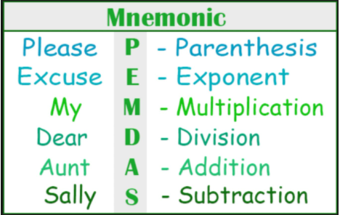

After you created your mnemonic, click on the 'Lab 1: Geologic Time Scale' words in Canvas to answer the following questions and submit your mnemonic.

GEOLOGIC TIME SCALE Name__________________________________

Print clearly the names of the geologic eons, eras, periods and epochs in the spaces provided. Write the absolute ages of the era boundaries in the double-line boxes.
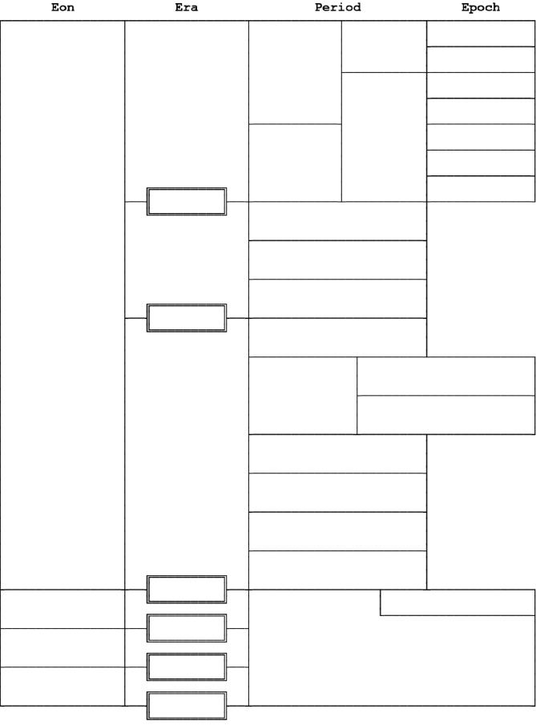
GEOLOGIC TIME SCALE Name__________________________________
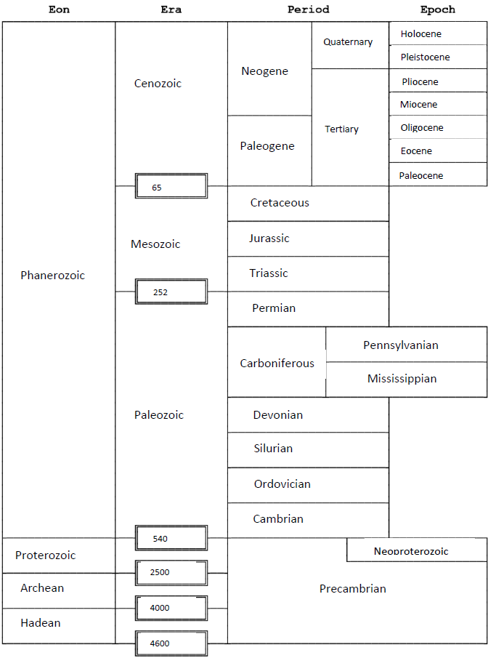

Additional resources that will help you understand the concepts better:

Rocks and minerals are the building blocks of planet Earth. They help us decipher events that have occurred during our long geologic past. Sedimentary rocks, which make up ~75% of the rocks on the surface of the earth are especially important for interpreting Earth History. Alongside sedimentary rock identification, sedimentary structures can help us understand depositional environments in which the rocks were deposited. Lastly, you will also learn about the principles of stratigraphy and what they can tell us about Earth History.

Videos to watch:

Rocks and Minerals
- The early Earth and Plate Tectonics: https://www.youtube.com/watch?v=QDqskltCixA&feature=related
- Atoms and elements explained: https://www.youtube.com/watch?v=q-BeFjoSuBY
- Volcanic evolution of the Pacific Northwest: 55 million year history: https://www.youtube.com/watch?v=3o3IJlAHhTE&t=87s
- Bowen's Reaction Series: https://www.youtube.com/watch?v=7wpu4H1_Gt8
- Metamorphism: https://www.youtube.com/watch?v=cWRX6lVQeck
- Pressure and Temperature: https://www.youtube.com/watch?v=MOKNfTrCecU
- Origin of Life: How life started on Earth: https://www.youtube.com/watch?v=QE5Js-9AzHo

Sedimentary Rocks
- Earth History: Rocks and PaleoEarth: https://www.youtube.com/watch?v=-2YEJBK9yJM
- Sedimentary Rocks overview (CJ Shorey): https://www.youtube.com/watch?v=1JLa392qA-k

Sedimentary Structures
- Depositional environments- turbidity flow: https://www.youtube.com/watch?v=bZniPhc_7N8
- Turbidity currents 2 lower contrast: https://www.youtube.com/watch?v=nwfbR_lWcn4
- MCC turbidity current demo: https://www.youtube.com/watch?v=KnNdkrs1uE8
- Turbidity current in a sinuous channel: https://www.youtube.com/watch?v=N1nUTJf0Awk
- Primary sedimentary structures (CJ Shorey): https://www.youtube.com/watch?v=uy9AzYkAP0c
- Laminar Flow: https://www.youtube.com/watch?v=p08_KlTKP50
- Turbulent boundary layer: https://www.youtube.com/watch?v=e1TbkLIDWys
- Cross-bedding video: https://www.youtube.com/watch?v=cJo0fTpJypg
- Mud clasts: ripping and entrainment: https://www.youtube.com/watch?v=z0RuqU0Rx1U
- Bioturbation - Worms at work: https://www.youtube.com/watch?v=n3wsUYg3XV0

Stratigraphy
- Why do rivers have deltas: https://www.youtube.com/watch?v=A47ythEcz74
- Depositional environments (CV Shorey): https://www.youtube.com/watch?v=lt05PRFfkCg&t=1s

Additional resources to help you:
- Rocks and Minerals (Mike Sammartano): https://www.youtube.com/watch?v=ZkHp_nnU9DY&t=267s

