CT - Cost Transfer (Expense to Expense)
Cost transfers are used when an expense is incorrectly processed on one budget or expense code and needs to be transferred to another. They may not be used to transfer income from one account to another. Cost transfers cannot cross the fiscal year unless it involves a grant budget.
What we require for approval:
- Document text.
- Cross reference text on the original document.
- Document reference numbers:
  - I doc, Z doc, J doc without ID_ journal type.
- The FOAPAL being credited matches the original document.
- Additional text required for CT’s over 90 days on both original doc and JV doc (see APM 20.14).
- Only grant cost transfers can cross fiscal year (‘22’ funds).

- Open Banner and navigate to FGAJVCD.
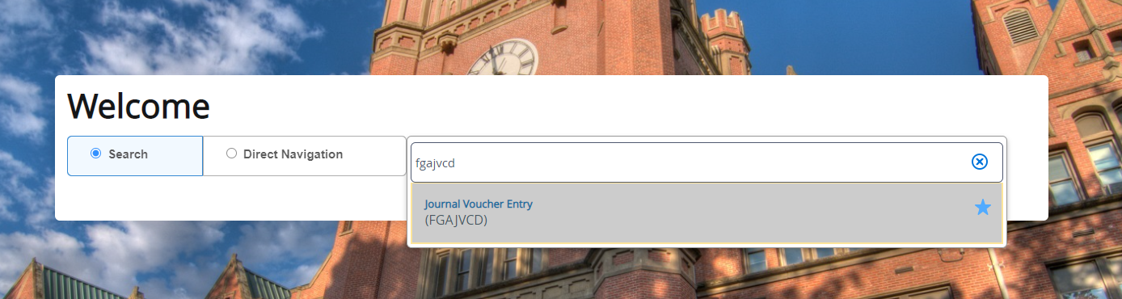

- From there, click Go to start a new journal. This will automatically populate a journal number, so you won’t have to worry about creating one.
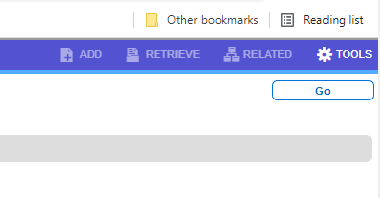

- In that screen, enter the total of the document. This will be the absolute value of all debits and credits in the journal entry. This is also where you will choose the date. In this screen go to the upper right hand corner and select the Related tab and add document text to the FOATEXT for the journal. This is required for approval.
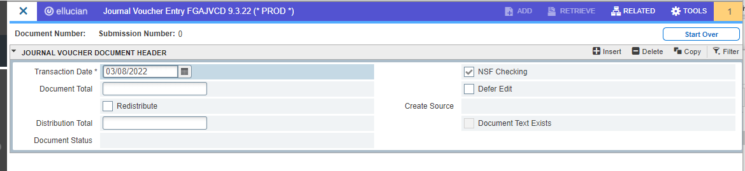
- Once the document text is entered and the total amount for the document is complete, press Alt + PgDn to go to the next section. This section is where you will complete the journal entry.
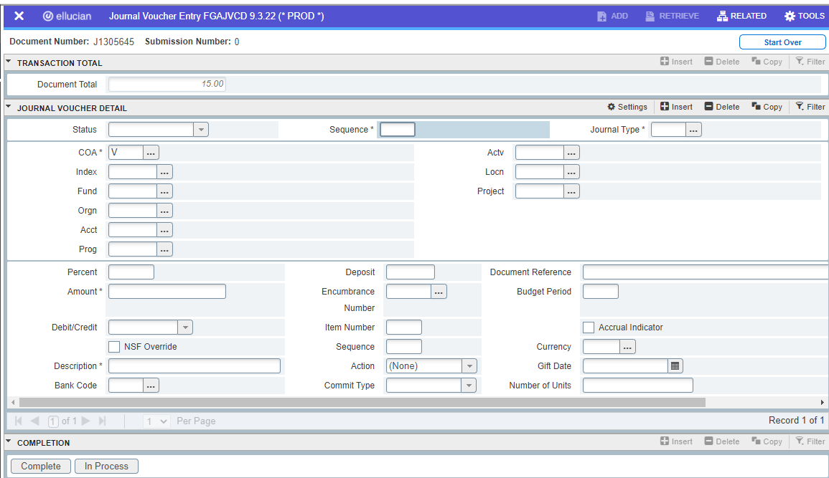

- Within this section, enter the FOAPAL information that matches the originating FOAPAL that you want to move and the new FOAPAL you want the cost to be recorded into.
- In the document reference section, record the original journal entry reference or purchase order invoice where the cost was originally recorded. You will also need to go to this originating entry and add into the FOATEXT an explanation of the costs that were moved and the journal entry that moved these costs.
- Once amounts have been entered, you can use the Related tab to select “Access Transaction Summary Info” to make sure all your items are as you want them to be. Once complete, press Alt + PgDn to get to the completion section and select complete.

