Intro to indexes:

Important concept when working with indexes (from Heather Nelson’s email to the dga listserv 8/19/18):

* An index basically is a quick way to set the *filters* for the data you want to see. It’s an easy way to get to the combination of filters you wish to see, but at least in the case of FRIGITD you can also take off or add filters (FOAPAL elements) to refine what you are looking for.
  + Entering the index and tabbing over will pull back the fund code, program code, and any activity, location or account codes that are associated with the index.
  + Tabbing over twice will pull back the grant code. The grant code is used in FRAGRNT and FRAGRNT FOATEXT (type GRT) if you want to see the basics of the award. Please do not make any edits to FOATEXT.
* Some of the indexes (specifically subawards) may have an associated account code so that any invoices charge correctly when they are entered. If you leave the account code field in place you will only see the expenses, because the budget and overhead account codes are different. If you want to see the overall balance for that fund you will need to take out the account code so that those other account codes display because the system is using the account code as one of your filters.

Example:

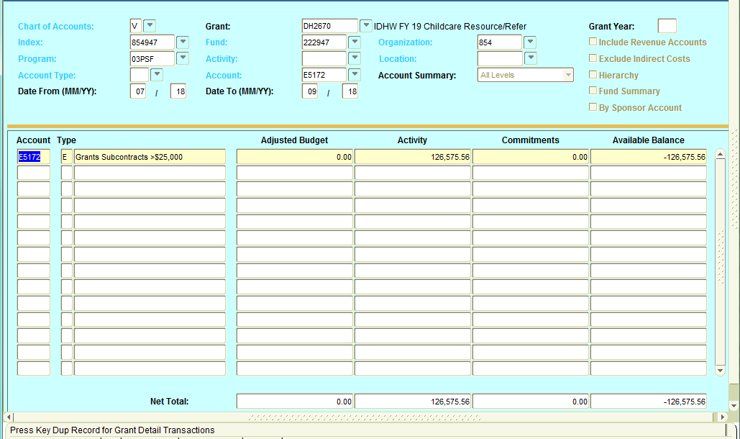

Remove Account E5172:

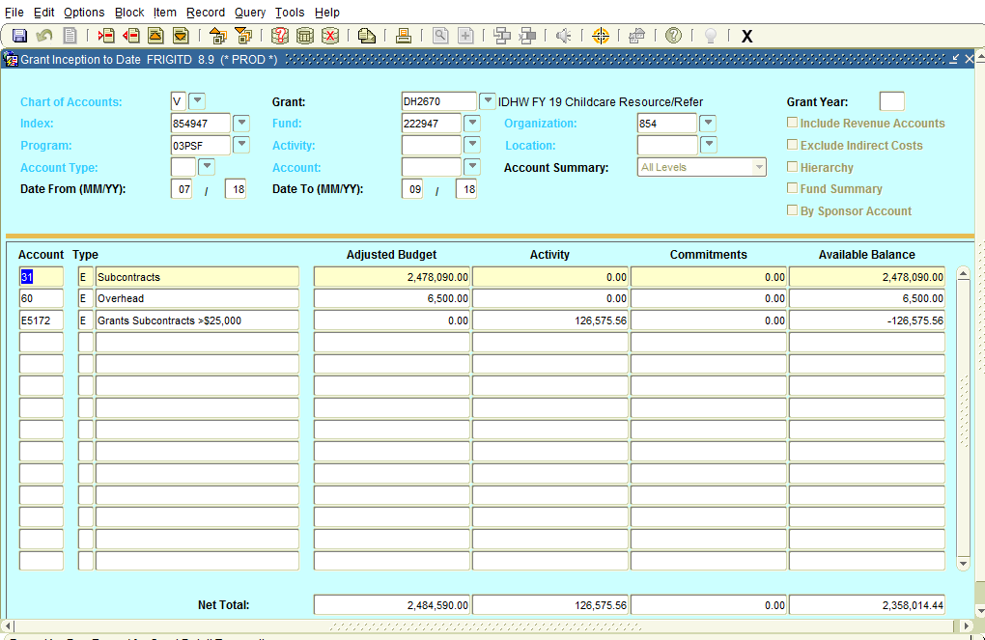

* Similarly, if you want to look by activity code, but don’t want to filter by fund you can blank out the fund code.
* One last thing we have seen is where a program code has been changed in the middle. Generally speaking we don’t allow that to happen, but if your numbers look strange try taking off the data in that field before assuming that something has been entered incorrectly.

2) How do I find my index?

Do you know your grant code? If yes, go to FTMFUND, F7, type grant code into the ‘grant’ field:

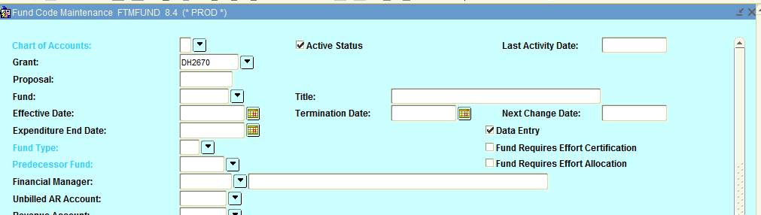F8:

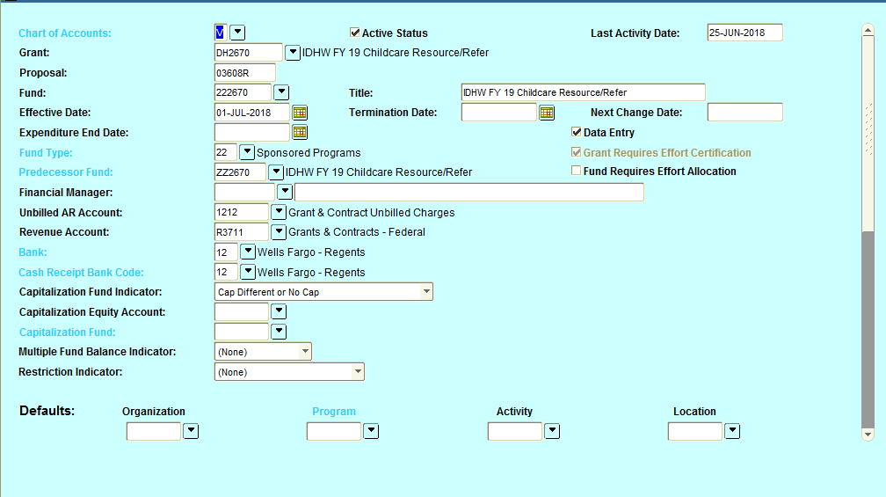

Grant codes with multiple indexes will have multiple fund records in FTMFUND. Find the fund code associated with the piece of the project that you are looking for (e.g. look at the title for an indicator of PI name, subaward, etc.). Choose the appropriate fund code, copy it (CTRL C) and go to FTMACCI.

F7, enter the fund code to ‘fund’ and F8:

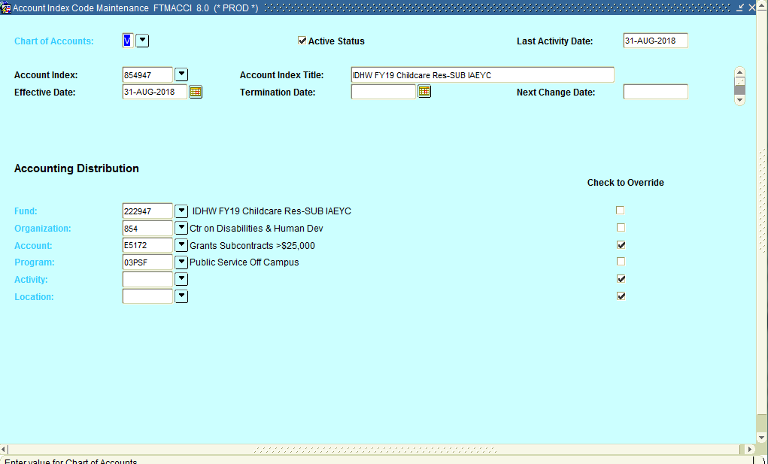 Your index is 854947 for this IAEYC Subaward. You can then use that to look at FRIGITD, FGIBAVL, enter expenses, EPAFs, etc.

Using FRIGITD in different ways:

Screen – FRIGITD

Additional click – “Fund Summary”

Shows budget and expense for each fund under a grant code, but not as pooled amounts

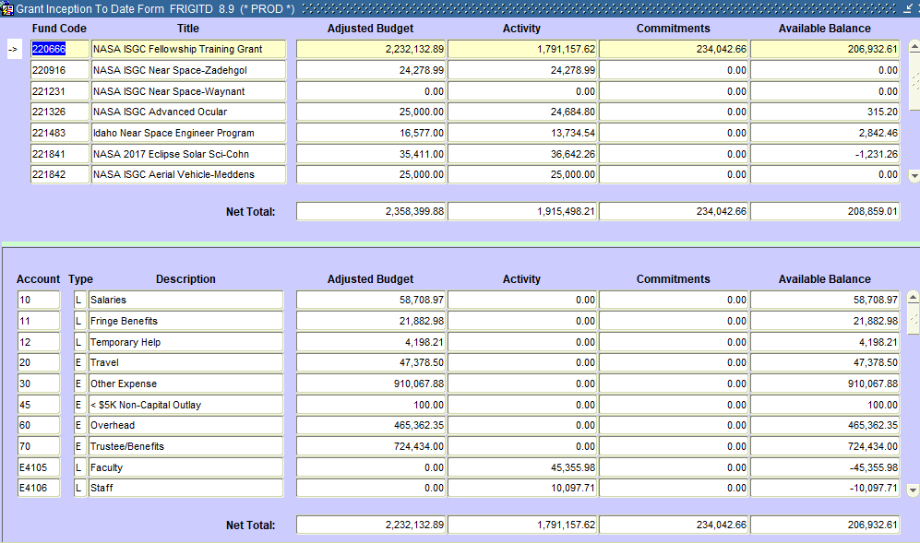

Screen – FRIGITD

Extra clicks – Account Summary Dropdown – Select “Level 2 Account Types” + “Fund Summary” checkbox

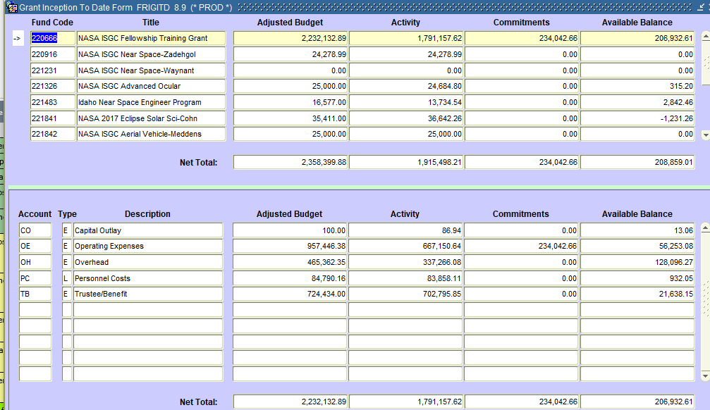

Other option – By “Level 1 Account Types”

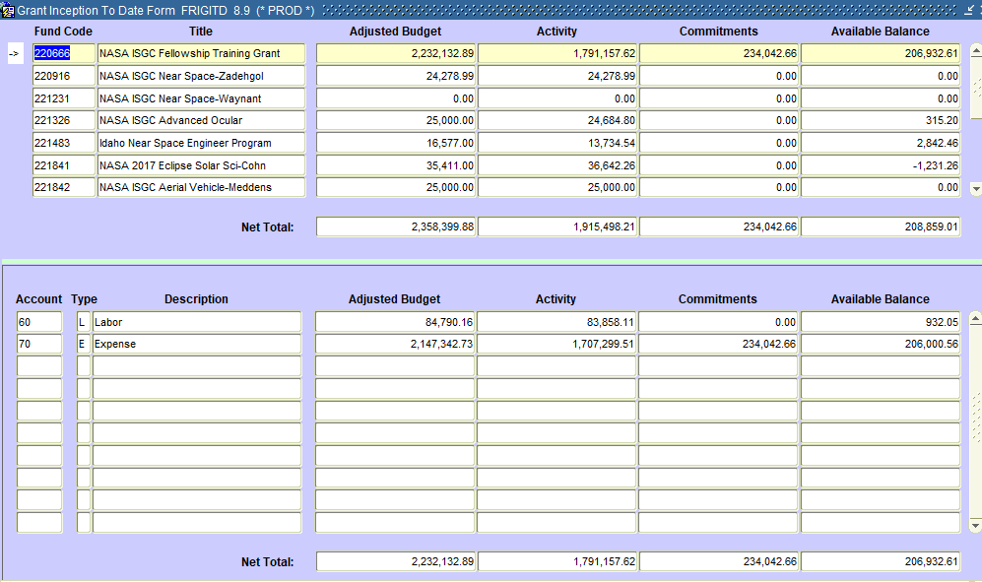

3e. Subawards in Chart V:



Grants with multiple ORGNs (PIs in different departments):

FOATEXT will note, on line 107 “multiple indexes on this grant code” if this was a Chart V setup. For setups converted from Chart 9, use the FTMFUND trick above, or search on the title in FTMACCI. E.g. if your title is ‘USDA NIFA Farmers Program’, try searching on ‘%NIFA%Farmers%Prog%’ in FTMACCI. In FTMFUND, find your associated FUND codes and then search in FTMACCI for each index record. It is also easy to pull an ARGOS report that crosswalks the indexes to the grant code, and this is what was suggested by the Controller’s office.

ARGOS Crosswalk: Finance/Production/Departmental Financial Reporting/Chart V Crosswalk Queries/Grant Code Crosswalk. Grant code is missing, but we have asked to have it added. Use FTMFUND and a fund code ot look up your grant code (fund codes can be found in FTMACCI by index and is also part of the crosswalk).