Argos Cost Share instructions

Go into the following Argos report:

Click on Run Dashboard and you will see:

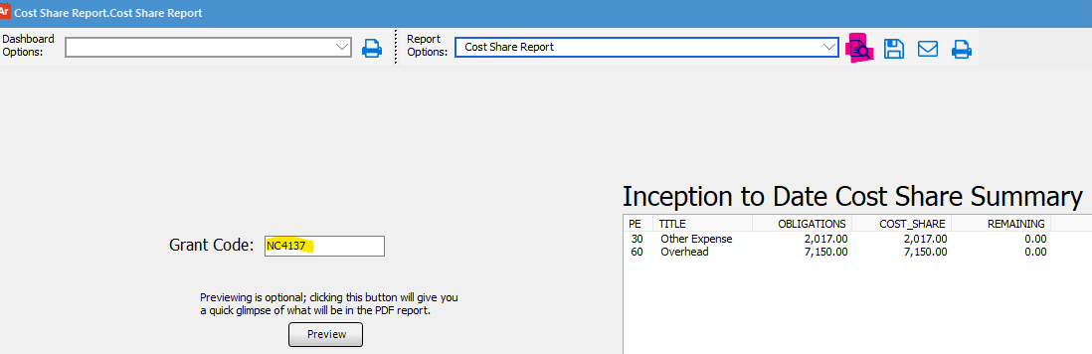

Type in the main grant code, not the C grant code in the yellow highlighted area. In the example above I was looking at NC4137. You can click the Preview to see the data. Select the Cost Share Report in the Report Options dropdown menu. Click on the report preview button (highlighted in pink by the Report Options box) and this will show you the report. You can print or save from that screen or go to the save and print buttons on this page.

