Step 1: Access VandalWeb:
Go to: Banner Self-Service
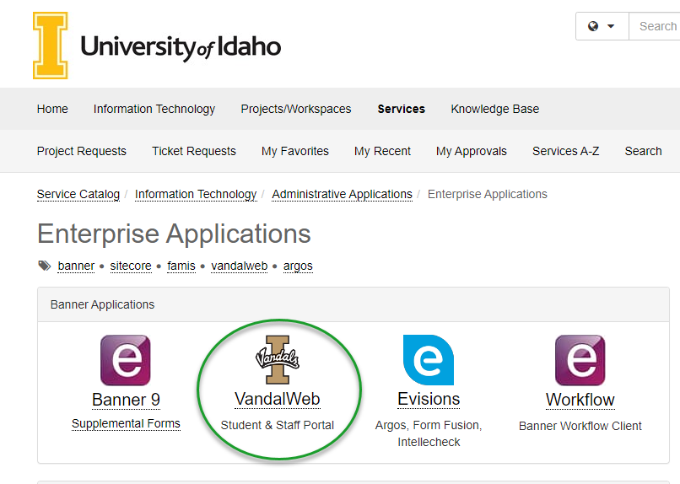

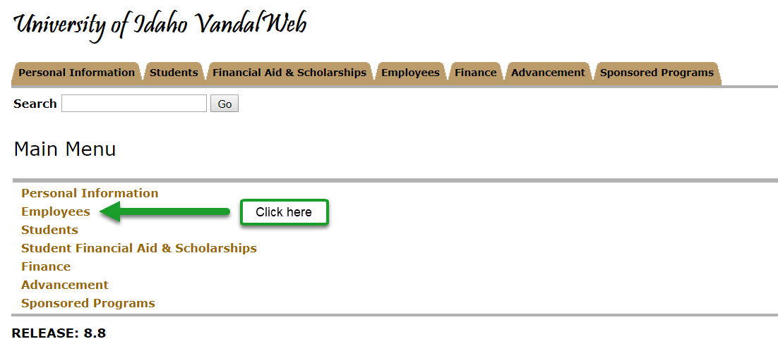
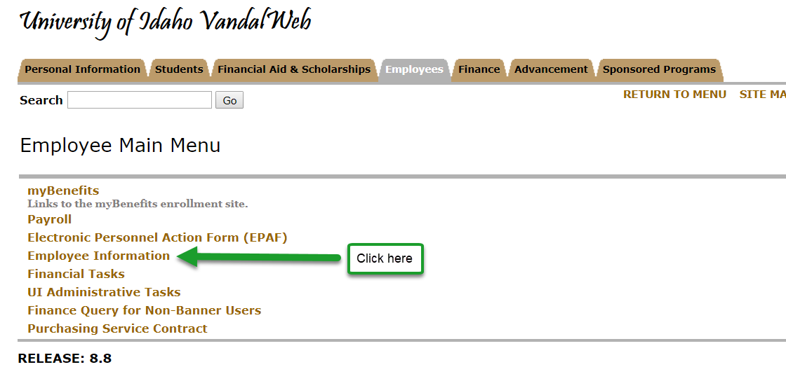
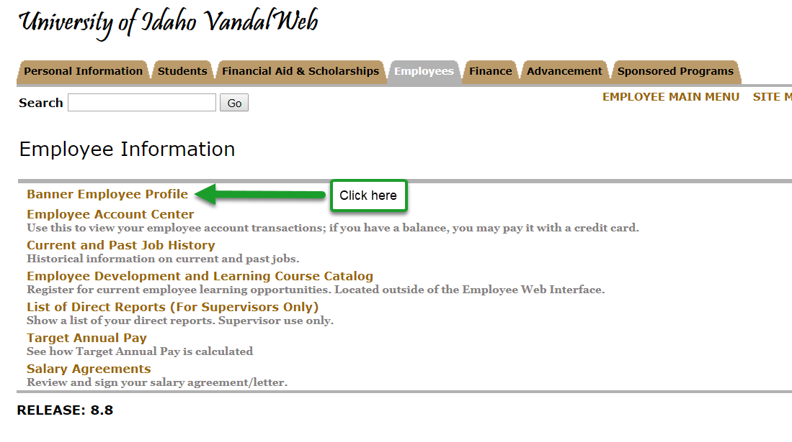

Step 2: Click the Effort Certification link located in the right hand lower box.

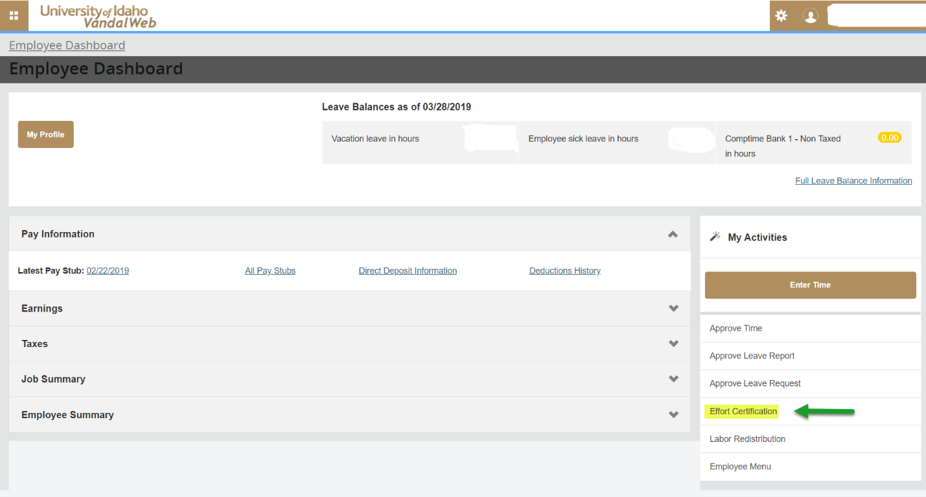

When the effort certification screen opens, it will default to “Certify My Effort”. This is where you will see your own effort report if you have one.
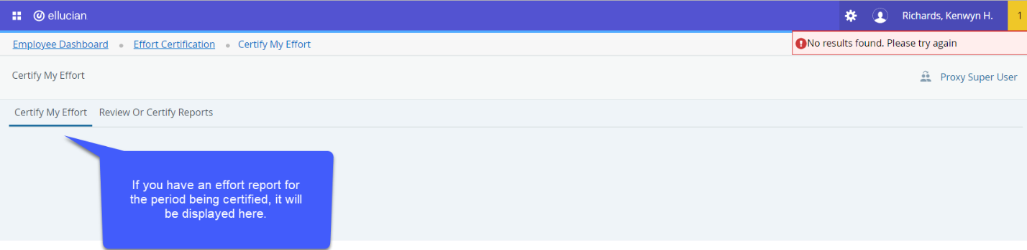
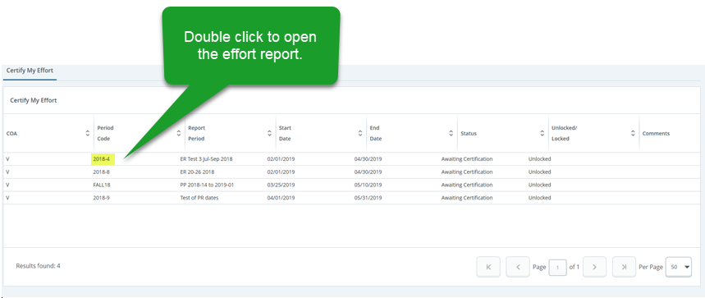
If you are required to certify for graduate students or acting as proxy, the reports will be displayed on the “Review Or Certify Reports” tab, which is only available when you have to certify effort reports for others.
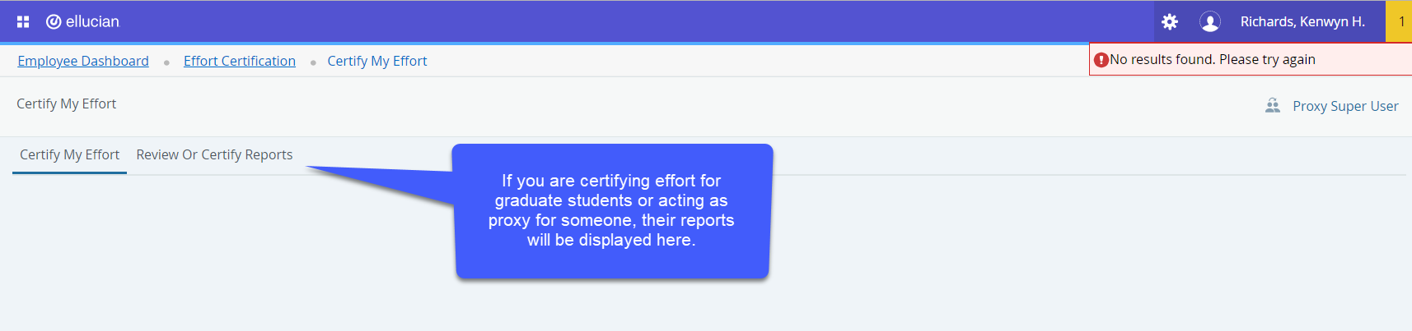
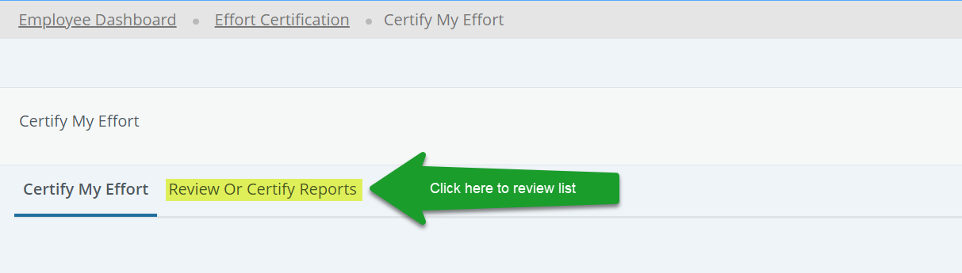
When you click “Review Or Certify Reports”, the advanced search box opens. Complete the box as shown below and click “Go”.
Note: If the “Advanced Search box” does not open, click on “Advanced Search” on the right of the screen (See below):

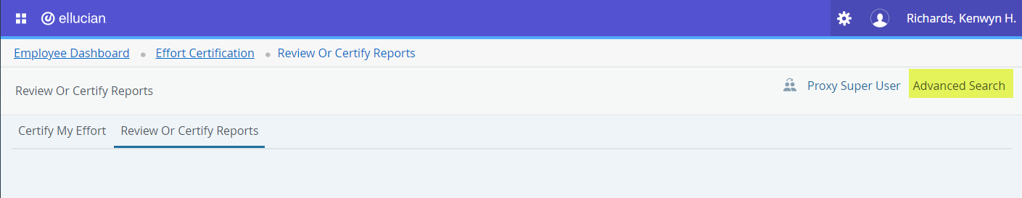

Under status, choose “Awaiting Certification”. Leave all other search boxes blank.
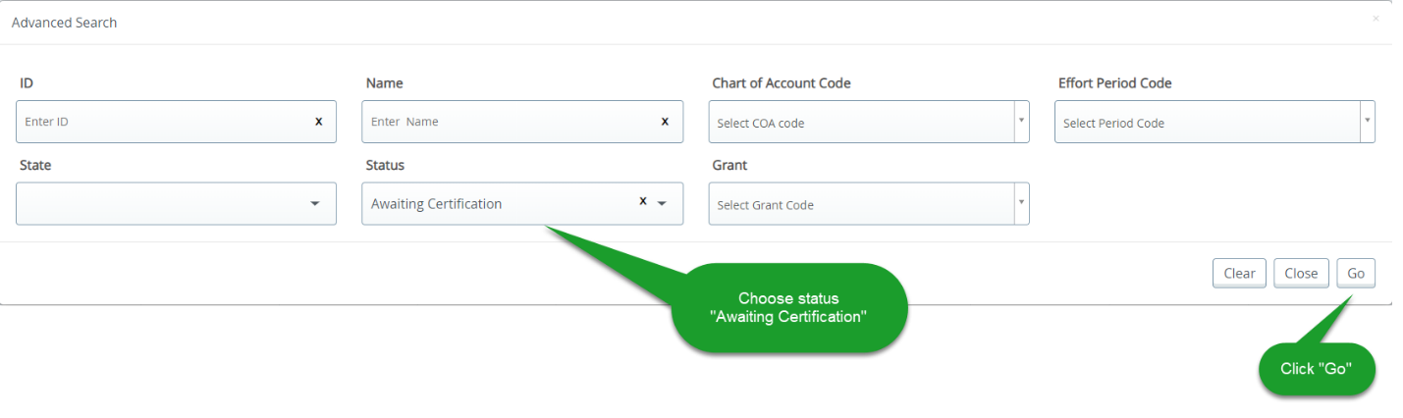

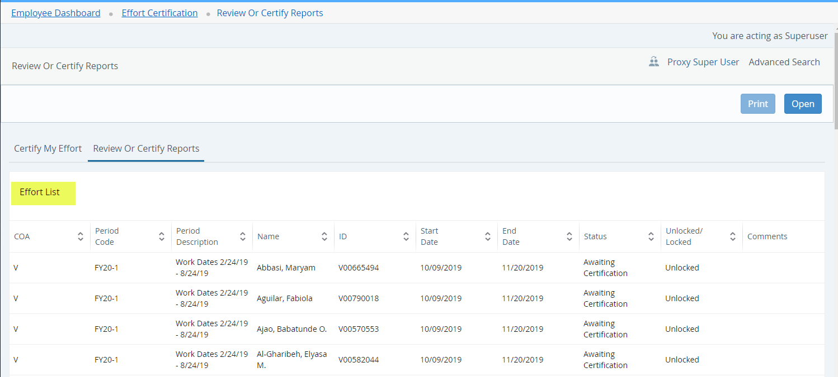
When the list is displayed, Principal Investigators (PIs) should see all non-temporary employees who worked on one of their grants in their “Effort List”. The system was setup in this way so that PIs could certify graduate student effort. If you are a PI and you see employees on your grant that are other available faculty or staff, DO NOT certify their effort. PIs are only responsible for certifying graduate student’s effort or for those employees not available to complete their own.
If you are the main PI and you see a graduate student that does not work directly for you, but for one of your Co-PIs, you may contact the Co-PI to verify the graduate student worked on the specified grant. The main PI will then need to certify the graduate student’s report. The Co-PI cannot certify the effort report, the main PI will have to certify.

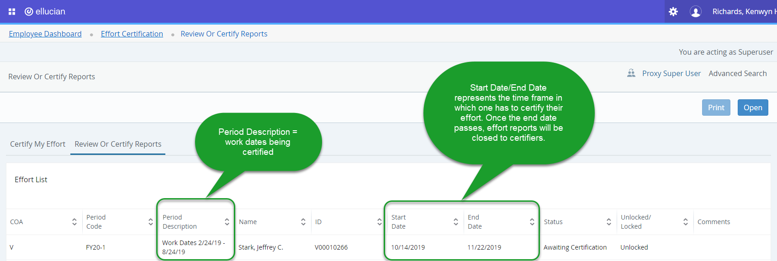

Note: the dates listed in “Period Description” represent the dates worked by the employee. The “Start” and “End” dates represent the time period in which one has to complete their effort certification. Once the end date passes, effort reports will be closed to certifiers.

To open a report, double-click on the person’s name.
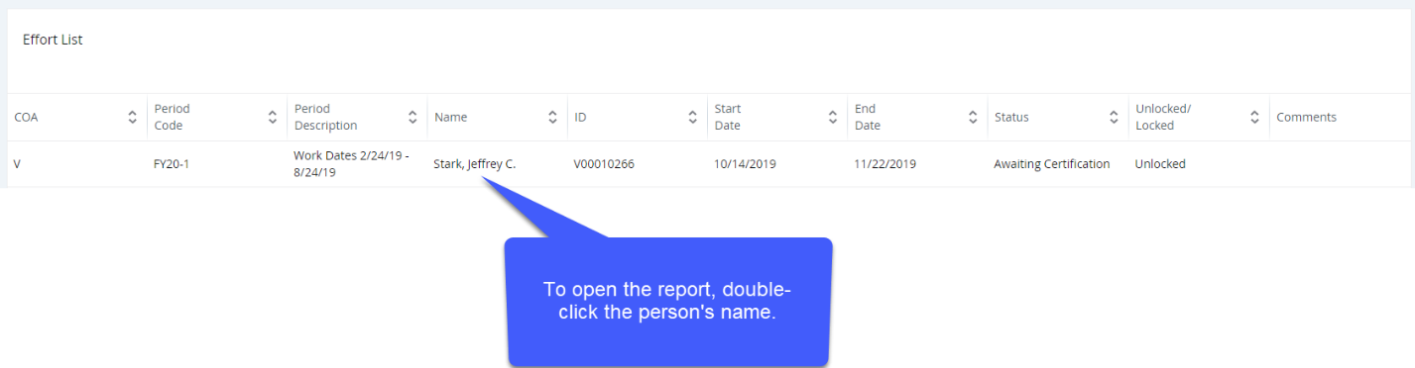
Once the report is open, review the effort indicated on each fund. If there are problems with the effort being reported, please contact osp-effort@uidaho.edu .
Step 3: Verify that each fund and effort percentage is reasonable (which is defined as being within + or – 5% in APM 45.09).
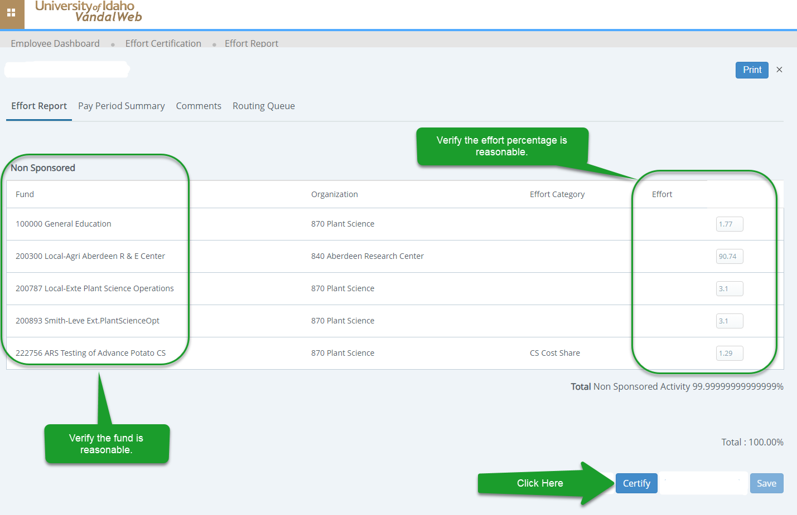

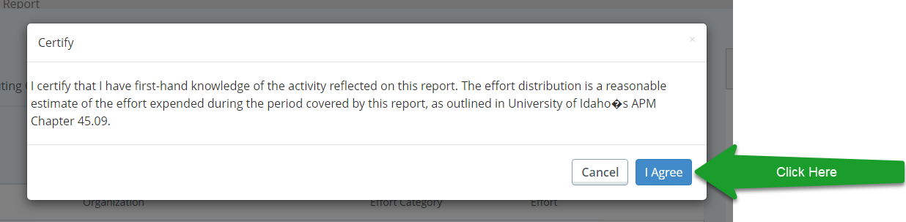

If you do not agree with the fund breakdown and percentages being reported, do not certify the report. Contact your departmental grant administrator and send notification to osp-effort@uidaho.edu that you have a discrepancy.
Once the effort report is certified successfully, you will see a message in the upper right corner indicating success. The status of the report will change to “Completed” and it will be locked if you are the last certifier. If the employee works for more than one PI or Financial Manager, additional certifications will be required before the report will show “Completed” and locked. To leave this screen, click the “x” to the right of the “Print” button.
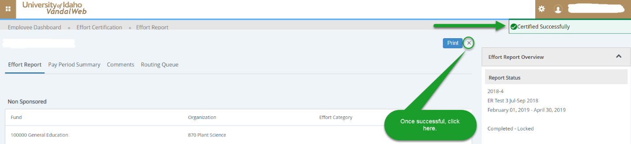
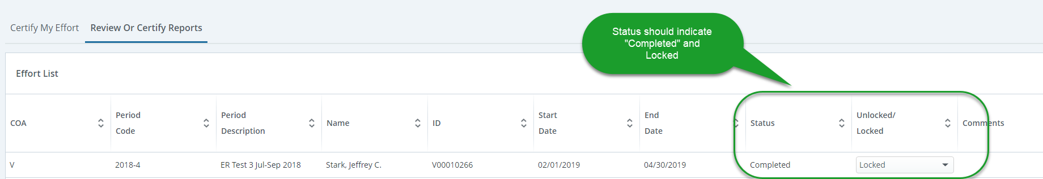

The process is complete. Thank you!

If there are any questions, please contact us at osp-effort@uidaho.edu

