IRB Protocol Submission Guide for VERAS
- Log into VERAS (Vandals Electronic Research Administration System) at https://veras.uidaho.edu using your University of Idaho single sign-on credentials. If you do not have an account then you will be prompted to request one when you log in.

- The Study Assistant section will allow you to “Add a New Study” or view “My Studies” by clicking on the appropriate box.
Adding a new IRB Protocol
- Click on “Add a New Study”
- Select “Study Application – IRB” and then “Start selected Application” 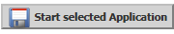
- Navigate through the application by clicking on “Save and Continue to Next Section” to move forward and the “Section view of Application” links to move between sections. The sections will not show up until you have saved through them. All questions with a red asterisk are required questions and you will not be able to move forward until these are completed.
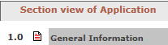
Note: Do not use the “Back” button or it will take you out of the application form (all completed information will have been saved and you can go back into the application if you accidentally hit this button).
You can start and come back but make sure to “Save Section” before exiting the application.
Here are some helpful tips for sections of the application:
- 2.0 - automatically lists the departments associated with personnel, you do not need to do anything in this section.
- 3.0 – this is where you can add personnel. The PI must be listed in section 3.1 but note that students are not eligible to serve as PI according to APM 45.22. Additional researchers can be added in section 3.2. Click on “Add User” to the right where you will be provided with search options such as first and last name. Click on the green checkmark to select the user to add to the protocol.
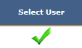
You will need to select the appropriate role for personnel in the dropdown menu below their name.
Click “Add User” again if you need to add multiple personnel.
The PI is automatically listed as a Study Contact but others can be added here if they would like to receive important notifications such as expiration notices. Note that if you are only listed as a study contact then you are not officially listed as study personnel.

The IRB Coordinator can create an account for personnel that are not affiliated with UI or “external members” by sending the name and email address to irb@uidaho.edu . External members are not able to log into VERAS but you can list them as personnel.

- 5.0 – this section contains important components of the application! Section 5.1 should list the expertise of the PI but you can list student experience as well in the text box if this is a student project. Section 5.4 has the main components which include the purpose, research design, participant population, and procedures.
Please note that there is a spell check for the text boxes but you will need to do this for each box if you chose to use this function. Click on the ABC with a checkmark in the upper left when you have the text box open.
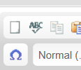

- 6.1 – this is a checklist that will determine if you will complete an exempt or non-exempt application. If you feel that your project can be submitted as exempt then select the last option. All other checkboxes will direct you to the non-exempt form.
There is a statement that refers to asking sensitive questions that are linked to their identity. Please contact the IRB Coordinator if you would like to discuss your project and determine if this box should be checked or not.

- Once you complete the application you will be directed to a new area that includes the sections below. You can advance to each section by clicking on “Save and Continue to Next Section” in the upper right.
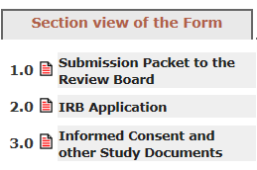

- 1. 0 provides basic information about the submission and section 1.4 asks for a lay summary of your project which can be a brief description.
- 2.0 provides the option to edit/view your application but you do not need to do anything here if no changes are needed.
- 3.0 is where you can upload any study documents including but not limited to consent forms, questionnaires, and recruitment materials.

- Once this section is completed you will be asked to exit the form if you are not ready to submit or to signoff and submit for review. If you are the PI then you will be given the option to “Signoff and Submit” which will send the submission to the IRB Coordinator for pre-review.
VERAS allows other research personnel including students to fill out the application and will send the submission to the PI for final review and signoff before going to the IRB Coordinator.
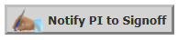
- There is one last step before the submission will actually be processed! This is the Submission Routing Signoff page. You will see a table of your submission components that you can review if needed and verify that everything is there. These are the study materials that will be sent to the IRB for review so if something is missing then you should go back and upload the document again. You will need check the “Approve” option then click on “Save Signoff” to move this out of your queue and onto the IRB or PI.

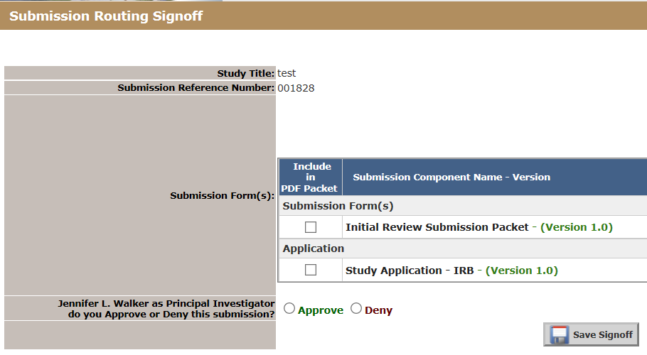

Note that the status of your study will change from “Draft” to “Pending – Submitted for Initial Review” once you have completed this step.

Please contact the IRB Coordinator with any questions – irb@uidaho.edu or 208-885-6340

